UPPSC Polytechnic Lecturer — Analog Electronics (subject-wise pool)
Question | 481
Type | MCQ
Body | In the circuit shown, a 5 V source drives a silicon diode (forward drop 0.7 V) in series with R = 2 kΩ. The diode current is:  दिखाए गए परिपथ में, एक 5 V स्रोत एक सिलिकॉन डायोड (अग्र वोल्टता पात 0.7 V) को R = 2 kΩ के श्रेणी में चलाता है। डायोड धारा है:  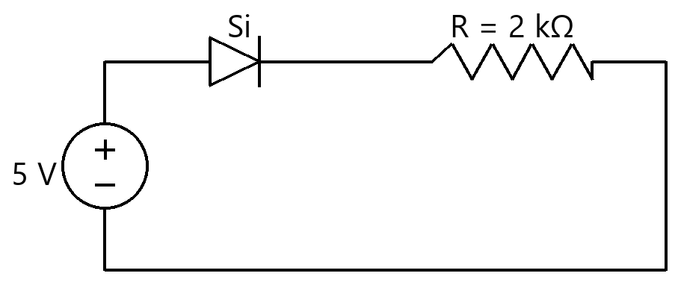
Option | 2.5 mA  2.5 mA
Option | 2.35 mA  2.35 mA
Option | 2.15 mA  2.15 mA
Option | 2.85 mA  2.85 mA
Correct | 3
Explanation | 1. Core Concept & Formula  A forward-biased silicon diode drops ~0.7 V; the rest of the source voltage appears across R, setting the current.  $\scriptstyle I = (V − 0.7) / R$  2. Calculation Steps  $\scriptstyle I = (5 − 0.7)/2 kΩ = 2.15 \text{mA}$  Final Answer: 2.15 mA
Subject | Analog Electronics
Topic | Diode and Its Applications (Diode Basics and Diode Circuit Analysis)
Correct Marks | 3
Incorrect Marks | 1
Hint | -
Video Solution | -
PYQ
OTS ID | AJEEEANE1120481

Question | 482
Type | MCQ
Body | In the circuit shown, a 10 V source drives a silicon diode (forward drop 0.7 V) in series with R = 4.65 kΩ. The diode current is:  दिखाए गए परिपथ में, एक 10 V स्रोत एक सिलिकॉन डायोड (अग्र वोल्टता पात 0.7 V) को R = 4.65 kΩ के श्रेणी में चलाता है। डायोड धारा है:  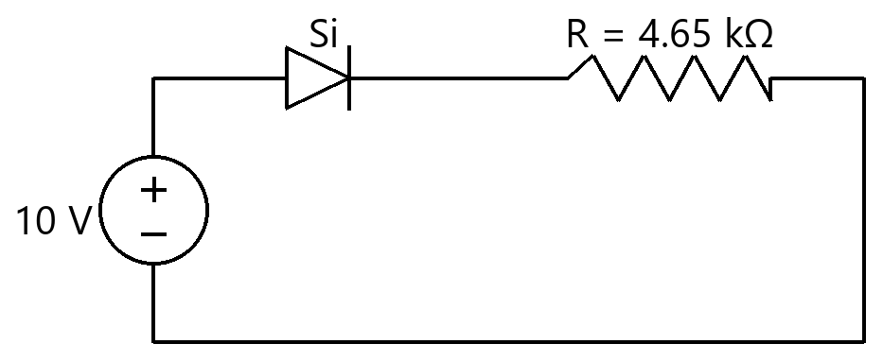
Option | 2.151 mA  2.151 mA
Option | 2.086 mA  2.086 mA
Option | 2.301 mA  2.301 mA
Option | 2.0 mA  2.0 mA
Correct | 4
Explanation | 1. Core Concept & Formula  A forward-biased silicon diode drops ~0.7 V; the rest of the source voltage appears across R, setting the current.  $\scriptstyle I = (V − 0.7) / R$  2. Calculation Steps  $\scriptstyle I = (10 − 0.7)/4.65 kΩ = 2.0 \text{mA}$  Final Answer: 2.0 mA
Subject | Analog Electronics
Topic | Diode and Its Applications (Diode Basics and Diode Circuit Analysis)
Correct Marks | 3
Incorrect Marks | 1
Hint | -
Video Solution | -
PYQ
OTS ID | AJEEEANE1120482

Question | 483
Type | MCQ
Body | In the circuit shown, a 7 V source drives a silicon diode (forward drop 0.7 V) in series with R = 3.15 kΩ. The diode current is:  दिखाए गए परिपथ में, एक 7 V स्रोत एक सिलिकॉन डायोड (अग्र वोल्टता पात 0.7 V) को R = 3.15 kΩ के श्रेणी में चलाता है। डायोड धारा है:  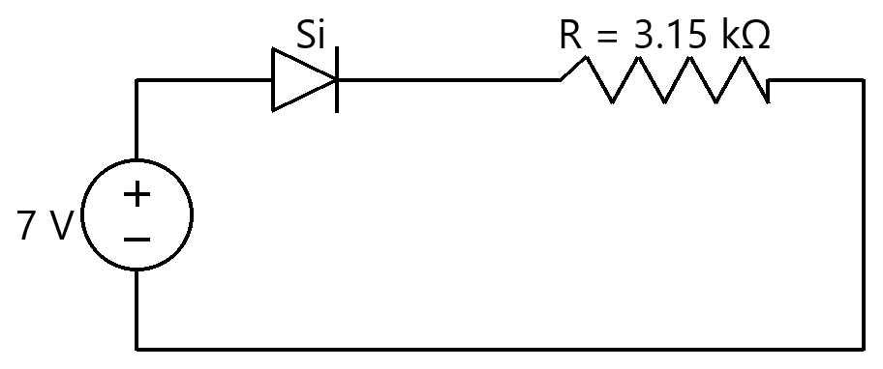
Option | 2.0 mA  2.0 mA
Option | 2.222 mA  2.222 mA
Option | 2.127 mA  2.127 mA
Option | 2.444 mA  2.444 mA
Correct | 1
Explanation | 1. Core Concept & Formula  A forward-biased silicon diode drops ~0.7 V; the rest of the source voltage appears across R, setting the current.  $\scriptstyle I = (V − 0.7) / R$  2. Calculation Steps  $\scriptstyle I = (7 − 0.7)/3.15 kΩ = 2.0 \text{mA}$  Final Answer: 2.0 mA
Subject | Analog Electronics
Topic | Diode and Its Applications (Diode Basics and Diode Circuit Analysis)
Correct Marks | 3
Incorrect Marks | 1
Hint | -
Video Solution | -
PYQ
OTS ID | AJEEEANE1120483

Question | 484
Type | MCQ
Body | In the circuit shown, a 12.7 V source drives a silicon diode (forward drop 0.7 V) in series with R = 6 kΩ. The diode current is:  दिखाए गए परिपथ में, एक 12.7 V स्रोत एक सिलिकॉन डायोड (अग्र वोल्टता पात 0.7 V) को R = 6 kΩ के श्रेणी में चलाता है। डायोड धारा है:  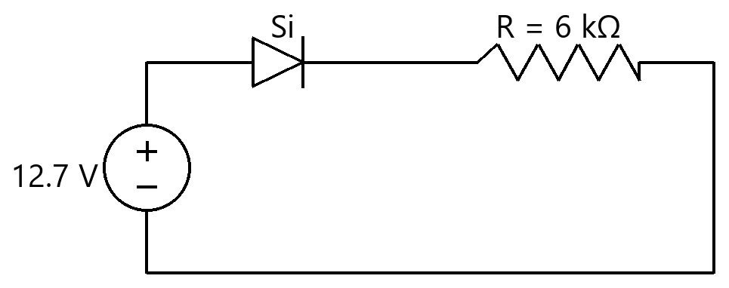
Option | 2.117 mA  2.117 mA
Option | 2.0 mA  2.0 mA
Option | 2.067 mA  2.067 mA
Option | 2.233 mA  2.233 mA
Correct | 2
Explanation | 1. Core Concept & Formula  A forward-biased silicon diode drops ~0.7 V; the rest of the source voltage appears across R, setting the current.  $\scriptstyle I = (V − 0.7) / R$  2. Calculation Steps  $\scriptstyle I = (12.7 − 0.7)/6 kΩ = 2.0 \text{mA}$  Final Answer: 2.0 mA
Subject | Analog Electronics
Topic | Diode and Its Applications (Diode Basics and Diode Circuit Analysis)
Correct Marks | 3
Incorrect Marks | 1
Hint | -
Video Solution | -
PYQ
OTS ID | AJEEEANE1120484

Question | 485
Type | MCQ
Body | In the circuit shown, a 5.7 V source drives a silicon diode (forward drop 0.7 V) in series with R = 5 kΩ. The diode current is:  दिखाए गए परिपथ में, एक 5.7 V स्रोत एक सिलिकॉन डायोड (अग्र वोल्टता पात 0.7 V) को R = 5 kΩ के श्रेणी में चलाता है। डायोड धारा है:  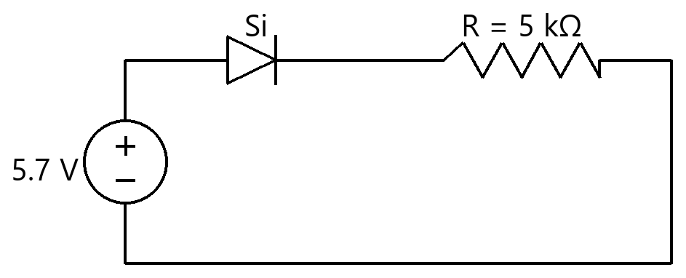
Option | 1.14 mA  1.14 mA
Option | 1.08 mA  1.08 mA
Option | 1.0 mA  1.0 mA
Option | 1.28 mA  1.28 mA
Correct | 3
Explanation | 1. Core Concept & Formula  A forward-biased silicon diode drops ~0.7 V; the rest of the source voltage appears across R, setting the current.  $\scriptstyle I = (V − 0.7) / R$  2. Calculation Steps  $\scriptstyle I = (5.7 − 0.7)/5 kΩ = 1.0 \text{mA}$  Final Answer: 1.0 mA
Subject | Analog Electronics
Topic | Diode and Its Applications (Diode Basics and Diode Circuit Analysis)
Correct Marks | 3
Incorrect Marks | 1
Hint | -
Video Solution | -
PYQ
OTS ID | AJEEEANE1120485

Question | 486
Type | MCQ
Body | In the circuit shown, a 10.7 V source drives a silicon diode (forward drop 0.7 V) in series with R = 10 kΩ. The diode current is:  दिखाए गए परिपथ में, एक 10.7 V स्रोत एक सिलिकॉन डायोड (अग्र वोल्टता पात 0.7 V) को R = 10 kΩ के श्रेणी में चलाता है। डायोड धारा है:  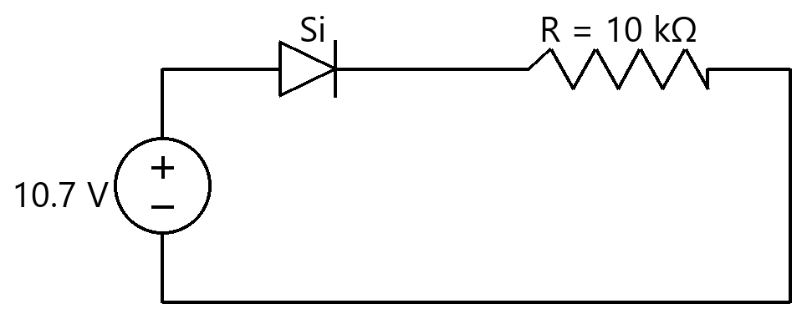
Option | 1.07 mA  1.07 mA
Option | 1.04 mA  1.04 mA
Option | 1.14 mA  1.14 mA
Option | 1.0 mA  1.0 mA
Correct | 4
Explanation | 1. Core Concept & Formula  A forward-biased silicon diode drops ~0.7 V; the rest of the source voltage appears across R, setting the current.  $\scriptstyle I = (V − 0.7) / R$  2. Calculation Steps  $\scriptstyle I = (10.7 − 0.7)/10 kΩ = 1.0 \text{mA}$  Final Answer: 1.0 mA
Subject | Analog Electronics
Topic | Diode and Its Applications (Diode Basics and Diode Circuit Analysis)
Correct Marks | 3
Incorrect Marks | 1
Hint | -
Video Solution | -
PYQ
OTS ID | AJEEEANE1120486

Question | 487
Type | MCQ
Body | In the circuit shown, a 2.7 V source drives a silicon diode (forward drop 0.7 V) in series with R = 1 kΩ. The diode current is:  दिखाए गए परिपथ में, एक 2.7 V स्रोत एक सिलिकॉन डायोड (अग्र वोल्टता पात 0.7 V) को R = 1 kΩ के श्रेणी में चलाता है। डायोड धारा है:  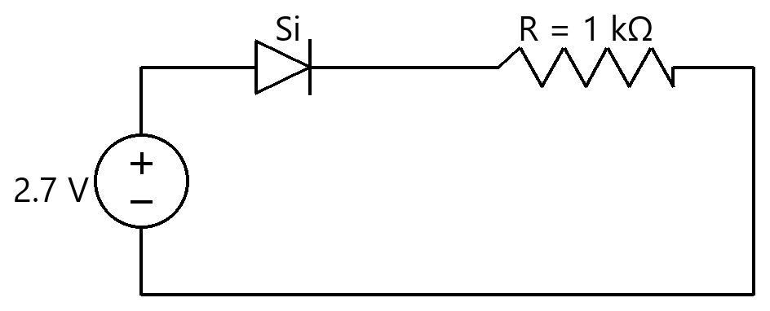
Option | 2.0 mA  2.0 mA
Option | 2.7 mA  2.7 mA
Option | 2.4 mA  2.4 mA
Option | 3.4 mA  3.4 mA
Correct | 1
Explanation | 1. Core Concept & Formula  A forward-biased silicon diode drops ~0.7 V; the rest of the source voltage appears across R, setting the current.  $\scriptstyle I = (V − 0.7) / R$  2. Calculation Steps  $\scriptstyle I = (2.7 − 0.7)/1 kΩ = 2.0 \text{mA}$  Final Answer: 2.0 mA
Subject | Analog Electronics
Topic | Diode and Its Applications (Diode Basics and Diode Circuit Analysis)
Correct Marks | 3
Incorrect Marks | 1
Hint | -
Video Solution | -
PYQ
OTS ID | AJEEEANE1120487

Question | 488
Type | MCQ
Body | For the half-wave rectifier shown (ideal diode, peak input $\scriptstyle V_m$ = 10 V, $\scriptstyle R_L$ = 1 kΩ), the DC output voltage and the diode PIV are:  दिखाए गए अर्ध-तरंग दिष्टकारी के लिए (आदर्श डायोड, शिखर निवेश $\scriptstyle V_m$ = 10 V, $\scriptstyle R_L$ = 1 kΩ), DC निर्गत वोल्टता तथा डायोड PIV हैं:  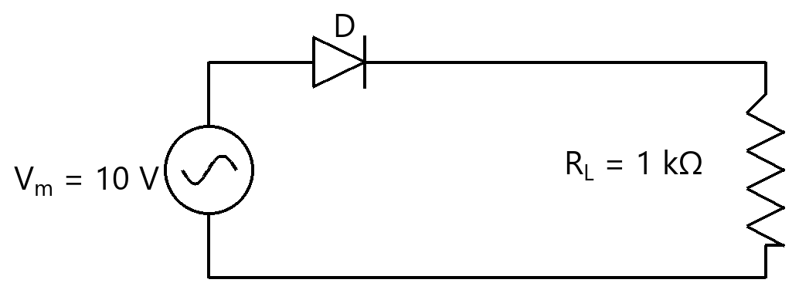
Option | $\scriptstyle V_{dc}$ = 6.37 V, PIV = 10 V  $\scriptstyle V_{dc}$ = 6.37 V, PIV = 10 V
Option | $\scriptstyle V_{dc}$ = 3.18 V, PIV = 10 V  $\scriptstyle V_{dc}$ = 3.18 V, PIV = 10 V
Option | $\scriptstyle V_{dc}$ = 5.0 V, PIV = 10 V  $\scriptstyle V_{dc}$ = 5.0 V, PIV = 10 V
Option | $\scriptstyle V_{dc}$ = 3.18 V, PIV = 20 V  $\scriptstyle V_{dc}$ = 3.18 V, PIV = 20 V
Correct | 2
Explanation | 1. Core Concept & Formula  A half-wave rectifier passes one half-cycle; its DC (average) value is $\scriptstyle V_m$/π, and the diode must block the full peak $\scriptstyle V_m$ in reverse.  $\scriptstyle V_{dc}$ = $\scriptstyle V_m$ / π  PIV = $\scriptstyle V_m$  2. Calculation Steps  $\scriptstyle V_{dc} = 10/π = 3.18 V$  $\scriptstyle \text{PIV} = 10 V$  Final Answer: $\scriptstyle V_{dc}$ = 3.18 V, PIV = 10 V
Subject | Analog Electronics
Topic | Diode and Its Applications (Rectifier Circuits)
Correct Marks | 3
Incorrect Marks | 1
Hint | -
Video Solution | -
PYQ
OTS ID | AJEEEANE1220488

Question | 489
Type | MCQ
Body | For the half-wave rectifier shown (ideal diode, peak input $\scriptstyle V_m$ = 20 V, $\scriptstyle R_L$ = 2 kΩ), the DC output voltage and the diode PIV are:  दिखाए गए अर्ध-तरंग दिष्टकारी के लिए (आदर्श डायोड, शिखर निवेश $\scriptstyle V_m$ = 20 V, $\scriptstyle R_L$ = 2 kΩ), DC निर्गत वोल्टता तथा डायोड PIV हैं:  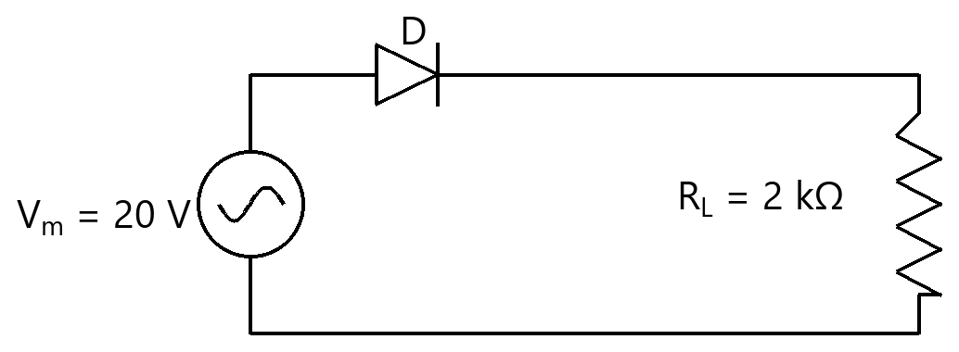
Option | $\scriptstyle V_{dc}$ = 12.73 V, PIV = 20 V  $\scriptstyle V_{dc}$ = 12.73 V, PIV = 20 V
Option | $\scriptstyle V_{dc}$ = 10.0 V, PIV = 20 V  $\scriptstyle V_{dc}$ = 10.0 V, PIV = 20 V
Option | $\scriptstyle V_{dc}$ = 6.37 V, PIV = 20 V  $\scriptstyle V_{dc}$ = 6.37 V, PIV = 20 V
Option | $\scriptstyle V_{dc}$ = 6.37 V, PIV = 40 V  $\scriptstyle V_{dc}$ = 6.37 V, PIV = 40 V
Correct | 3
Explanation | 1. Core Concept & Formula  A half-wave rectifier passes one half-cycle; its DC (average) value is $\scriptstyle V_m$/π, and the diode must block the full peak $\scriptstyle V_m$ in reverse.  $\scriptstyle V_{dc}$ = $\scriptstyle V_m$ / π  PIV = $\scriptstyle V_m$  2. Calculation Steps  $\scriptstyle V_{dc} = 20/π = 6.37 V$  $\scriptstyle \text{PIV} = 20 V$  Final Answer: $\scriptstyle V_{dc}$ = 6.37 V, PIV = 20 V
Subject | Analog Electronics
Topic | Diode and Its Applications (Rectifier Circuits)
Correct Marks | 3
Incorrect Marks | 1
Hint | -
Video Solution | -
PYQ
OTS ID | AJEEEANE1220489

Question | 490
Type | MCQ
Body | For the half-wave rectifier shown (ideal diode, peak input $\scriptstyle V_m$ = 15 V, $\scriptstyle R_L$ = 1 kΩ), the DC output voltage and the diode PIV are:  दिखाए गए अर्ध-तरंग दिष्टकारी के लिए (आदर्श डायोड, शिखर निवेश $\scriptstyle V_m$ = 15 V, $\scriptstyle R_L$ = 1 kΩ), DC निर्गत वोल्टता तथा डायोड PIV हैं:  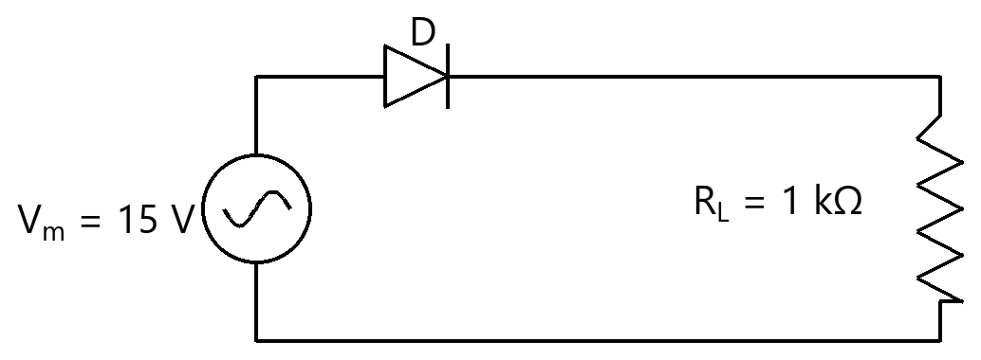
Option | $\scriptstyle V_{dc}$ = 9.55 V, PIV = 15 V  $\scriptstyle V_{dc}$ = 9.55 V, PIV = 15 V
Option | $\scriptstyle V_{dc}$ = 7.5 V, PIV = 15 V  $\scriptstyle V_{dc}$ = 7.5 V, PIV = 15 V
Option | $\scriptstyle V_{dc}$ = 4.77 V, PIV = 30 V  $\scriptstyle V_{dc}$ = 4.77 V, PIV = 30 V
Option | $\scriptstyle V_{dc}$ = 4.77 V, PIV = 15 V  $\scriptstyle V_{dc}$ = 4.77 V, PIV = 15 V
Correct | 4
Explanation | 1. Core Concept & Formula  A half-wave rectifier passes one half-cycle; its DC (average) value is $\scriptstyle V_m$/π, and the diode must block the full peak $\scriptstyle V_m$ in reverse.  $\scriptstyle V_{dc}$ = $\scriptstyle V_m$ / π  PIV = $\scriptstyle V_m$  2. Calculation Steps  $\scriptstyle V_{dc} = 15/π = 4.77 V$  $\scriptstyle \text{PIV} = 15 V$  Final Answer: $\scriptstyle V_{dc}$ = 4.77 V, PIV = 15 V
Subject | Analog Electronics
Topic | Diode and Its Applications (Rectifier Circuits)
Correct Marks | 3
Incorrect Marks | 1
Hint | -
Video Solution | -
PYQ
OTS ID | AJEEEANE1220490

Question | 491
Type | MCQ
Body | For the half-wave rectifier shown (ideal diode, peak input $\scriptstyle V_m$ = 100 V, $\scriptstyle R_L$ = 5 kΩ), the DC output voltage and the diode PIV are:  दिखाए गए अर्ध-तरंग दिष्टकारी के लिए (आदर्श डायोड, शिखर निवेश $\scriptstyle V_m$ = 100 V, $\scriptstyle R_L$ = 5 kΩ), DC निर्गत वोल्टता तथा डायोड PIV हैं:  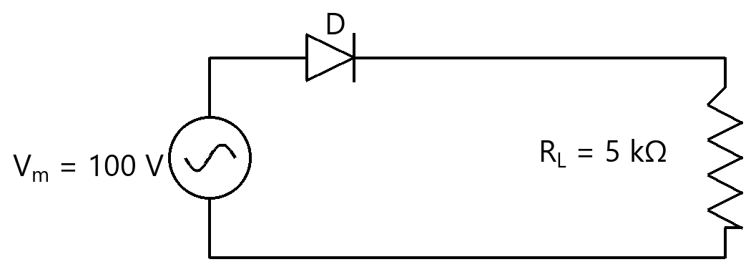
Option | $\scriptstyle V_{dc}$ = 31.83 V, PIV = 100 V  $\scriptstyle V_{dc}$ = 31.83 V, PIV = 100 V
Option | $\scriptstyle V_{dc}$ = 63.66 V, PIV = 100 V  $\scriptstyle V_{dc}$ = 63.66 V, PIV = 100 V
Option | $\scriptstyle V_{dc}$ = 50.0 V, PIV = 100 V  $\scriptstyle V_{dc}$ = 50.0 V, PIV = 100 V
Option | $\scriptstyle V_{dc}$ = 31.83 V, PIV = 200 V  $\scriptstyle V_{dc}$ = 31.83 V, PIV = 200 V
Correct | 1
Explanation | 1. Core Concept & Formula  A half-wave rectifier passes one half-cycle; its DC (average) value is $\scriptstyle V_m$/π, and the diode must block the full peak $\scriptstyle V_m$ in reverse.  $\scriptstyle V_{dc}$ = $\scriptstyle V_m$ / π  PIV = $\scriptstyle V_m$  2. Calculation Steps  $\scriptstyle V_{dc} = 100/π = 31.83 V$  $\scriptstyle \text{PIV} = 100 V$  Final Answer: $\scriptstyle V_{dc}$ = 31.83 V, PIV = 100 V
Subject | Analog Electronics
Topic | Diode and Its Applications (Rectifier Circuits)
Correct Marks | 3
Incorrect Marks | 1
Hint | -
Video Solution | -
PYQ
OTS ID | AJEEEANE1220491

Question | 492
Type | MCQ
Body | For the half-wave rectifier shown (ideal diode, peak input $\scriptstyle V_m$ = 50 V, $\scriptstyle R_L$ = 2 kΩ), the DC output voltage and the diode PIV are:  दिखाए गए अर्ध-तरंग दिष्टकारी के लिए (आदर्श डायोड, शिखर निवेश $\scriptstyle V_m$ = 50 V, $\scriptstyle R_L$ = 2 kΩ), DC निर्गत वोल्टता तथा डायोड PIV हैं:  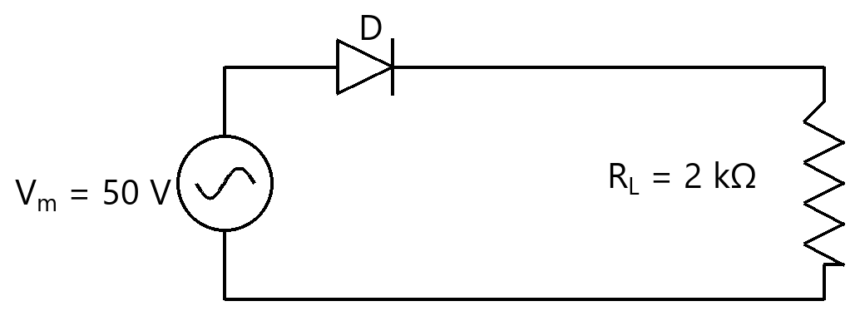
Option | $\scriptstyle V_{dc}$ = 31.83 V, PIV = 50 V  $\scriptstyle V_{dc}$ = 31.83 V, PIV = 50 V
Option | $\scriptstyle V_{dc}$ = 15.92 V, PIV = 50 V  $\scriptstyle V_{dc}$ = 15.92 V, PIV = 50 V
Option | $\scriptstyle V_{dc}$ = 25.0 V, PIV = 50 V  $\scriptstyle V_{dc}$ = 25.0 V, PIV = 50 V
Option | $\scriptstyle V_{dc}$ = 15.92 V, PIV = 100 V  $\scriptstyle V_{dc}$ = 15.92 V, PIV = 100 V
Correct | 2
Explanation | 1. Core Concept & Formula  A half-wave rectifier passes one half-cycle; its DC (average) value is $\scriptstyle V_m$/π, and the diode must block the full peak $\scriptstyle V_m$ in reverse.  $\scriptstyle V_{dc}$ = $\scriptstyle V_m$ / π  PIV = $\scriptstyle V_m$  2. Calculation Steps  $\scriptstyle V_{dc} = 50/π = 15.92 V$  $\scriptstyle \text{PIV} = 50 V$  Final Answer: $\scriptstyle V_{dc}$ = 15.92 V, PIV = 50 V
Subject | Analog Electronics
Topic | Diode and Its Applications (Rectifier Circuits)
Correct Marks | 3
Incorrect Marks | 1
Hint | -
Video Solution | -
PYQ
OTS ID | AJEEEANE1220492

Question | 493
Type | MCQ
Body | For the half-wave rectifier shown (ideal diode, peak input $\scriptstyle V_m$ = 12 V, $\scriptstyle R_L$ = 1 kΩ), the DC output voltage and the diode PIV are:  दिखाए गए अर्ध-तरंग दिष्टकारी के लिए (आदर्श डायोड, शिखर निवेश $\scriptstyle V_m$ = 12 V, $\scriptstyle R_L$ = 1 kΩ), DC निर्गत वोल्टता तथा डायोड PIV हैं:  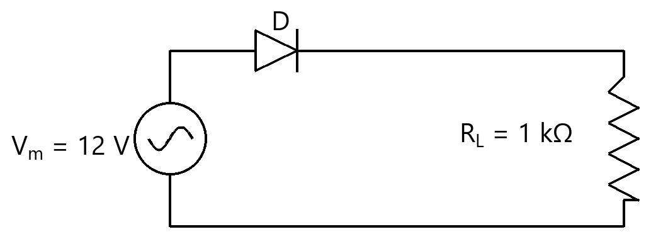
Option | $\scriptstyle V_{dc}$ = 7.64 V, PIV = 12 V  $\scriptstyle V_{dc}$ = 7.64 V, PIV = 12 V
Option | $\scriptstyle V_{dc}$ = 6.0 V, PIV = 12 V  $\scriptstyle V_{dc}$ = 6.0 V, PIV = 12 V
Option | $\scriptstyle V_{dc}$ = 3.82 V, PIV = 12 V  $\scriptstyle V_{dc}$ = 3.82 V, PIV = 12 V
Option | $\scriptstyle V_{dc}$ = 3.82 V, PIV = 24 V  $\scriptstyle V_{dc}$ = 3.82 V, PIV = 24 V
Correct | 3
Explanation | 1. Core Concept & Formula  A half-wave rectifier passes one half-cycle; its DC (average) value is $\scriptstyle V_m$/π, and the diode must block the full peak $\scriptstyle V_m$ in reverse.  $\scriptstyle V_{dc}$ = $\scriptstyle V_m$ / π  PIV = $\scriptstyle V_m$  2. Calculation Steps  $\scriptstyle V_{dc} = 12/π = 3.82 V$  $\scriptstyle \text{PIV} = 12 V$  Final Answer: $\scriptstyle V_{dc}$ = 3.82 V, PIV = 12 V
Subject | Analog Electronics
Topic | Diode and Its Applications (Rectifier Circuits)
Correct Marks | 3
Incorrect Marks | 1
Hint | -
Video Solution | -
PYQ
OTS ID | AJEEEANE1220493

Question | 494
Type | MCQ
Body | For the half-wave rectifier shown (ideal diode, peak input $\scriptstyle V_m$ = 24 V, $\scriptstyle R_L$ = 2 kΩ), the DC output voltage and the diode PIV are:  दिखाए गए अर्ध-तरंग दिष्टकारी के लिए (आदर्श डायोड, शिखर निवेश $\scriptstyle V_m$ = 24 V, $\scriptstyle R_L$ = 2 kΩ), DC निर्गत वोल्टता तथा डायोड PIV हैं:  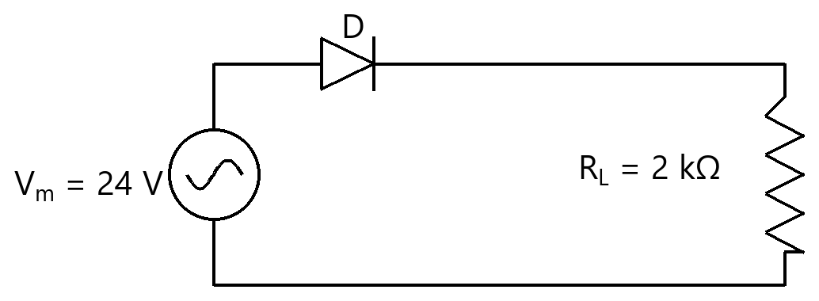
Option | $\scriptstyle V_{dc}$ = 15.28 V, PIV = 24 V  $\scriptstyle V_{dc}$ = 15.28 V, PIV = 24 V
Option | $\scriptstyle V_{dc}$ = 12.0 V, PIV = 24 V  $\scriptstyle V_{dc}$ = 12.0 V, PIV = 24 V
Option | $\scriptstyle V_{dc}$ = 7.64 V, PIV = 48 V  $\scriptstyle V_{dc}$ = 7.64 V, PIV = 48 V
Option | $\scriptstyle V_{dc}$ = 7.64 V, PIV = 24 V  $\scriptstyle V_{dc}$ = 7.64 V, PIV = 24 V
Correct | 4
Explanation | 1. Core Concept & Formula  A half-wave rectifier passes one half-cycle; its DC (average) value is $\scriptstyle V_m$/π, and the diode must block the full peak $\scriptstyle V_m$ in reverse.  $\scriptstyle V_{dc}$ = $\scriptstyle V_m$ / π  PIV = $\scriptstyle V_m$  2. Calculation Steps  $\scriptstyle V_{dc} = 24/π = 7.64 V$  $\scriptstyle \text{PIV} = 24 V$  Final Answer: $\scriptstyle V_{dc}$ = 7.64 V, PIV = 24 V
Subject | Analog Electronics
Topic | Diode and Its Applications (Rectifier Circuits)
Correct Marks | 3
Incorrect Marks | 1
Hint | -
Video Solution | -
PYQ
OTS ID | AJEEEANE1220494

Question | 495
Type | MCQ
Body | In the positive shunt clipper shown, a ±10 V peak sine input passes through R = 1 kΩ; the diode (Si, 0.7 V) in series with a 3 V battery clips the output. The positive peak of $\scriptstyle V_o$ is clipped to:  दिखाए गए धनात्मक शंट क्लिपर में, ±10 V शिखर ज्या निवेश R = 1 kΩ से गुजरता है; 3 V बैटरी के श्रेणी में डायोड (Si, 0.7 V) निर्गत को क्लिप करता है। $\scriptstyle V_o$ का धनात्मक शिखर किस पर क्लिप होता है:  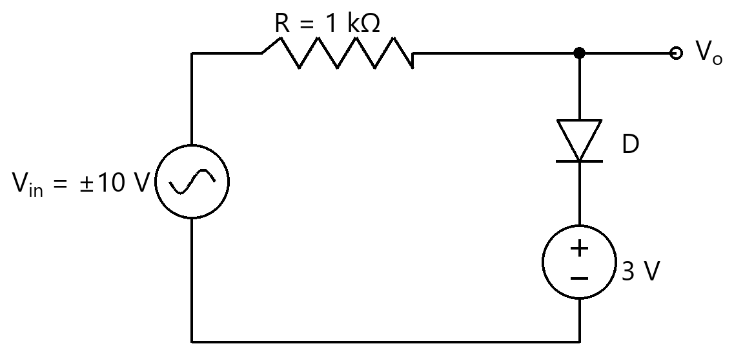
Option | +3.7 V  +3.7 V
Option | +3 V  +3 V
Option | +2.3 V  +2.3 V
Option | +10 V  +10 V
Correct | 1
Explanation | 1. Core Concept & Formula  The shunt diode conducts once the output tries to exceed the battery voltage plus one diode drop, holding the positive peak at Vb + 0.7 V.  $\scriptstyle V_{\text{clip}} = \text{Vb} + 0.7 V$  2. Calculation Steps  $\scriptstyle V_{\text{clip}} = 3 + 0.7 = 3.7 V$  Final Answer: +3.7 V
Subject | Analog Electronics
Topic | Diode and Its Applications (Wave Shaping Circuits)
Correct Marks | 3
Incorrect Marks | 1
Hint | -
Video Solution | -
PYQ
OTS ID | AJEEEANE1530495

Question | 496
Type | MCQ
Body | In the positive shunt clipper shown, a ±12 V peak sine input passes through R = 1 kΩ; the diode (Si, 0.7 V) in series with a 5 V battery clips the output. The positive peak of $\scriptstyle V_o$ is clipped to:  दिखाए गए धनात्मक शंट क्लिपर में, ±12 V शिखर ज्या निवेश R = 1 kΩ से गुजरता है; 5 V बैटरी के श्रेणी में डायोड (Si, 0.7 V) निर्गत को क्लिप करता है। $\scriptstyle V_o$ का धनात्मक शिखर किस पर क्लिप होता है:  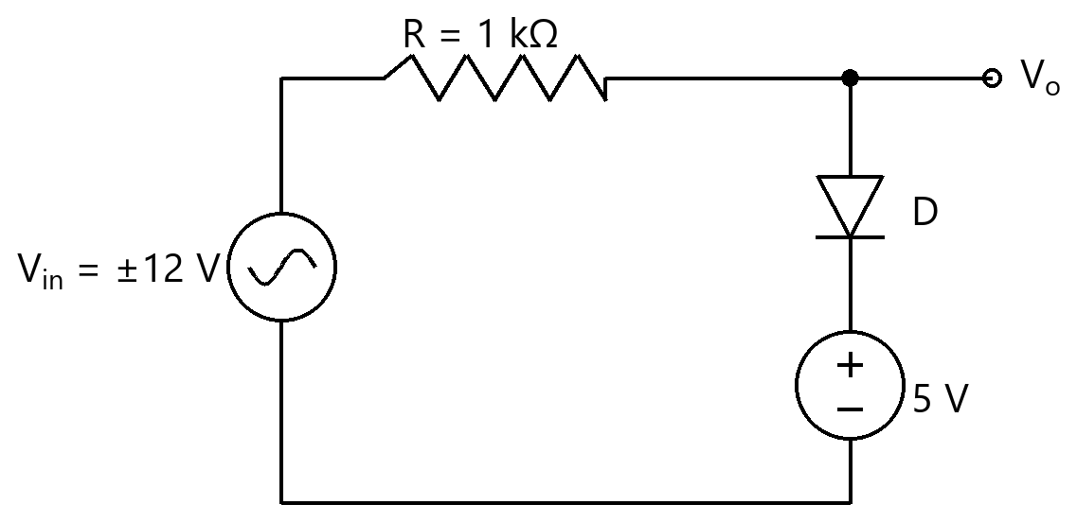
Option | +5 V  +5 V
Option | +5.7 V  +5.7 V
Option | +4.3 V  +4.3 V
Option | +12 V  +12 V
Correct | 2
Explanation | 1. Core Concept & Formula  The shunt diode conducts once the output tries to exceed the battery voltage plus one diode drop, holding the positive peak at Vb + 0.7 V.  $\scriptstyle V_{\text{clip}} = \text{Vb} + 0.7 V$  2. Calculation Steps  $\scriptstyle V_{\text{clip}} = 5 + 0.7 = 5.7 V$  Final Answer: +5.7 V
Subject | Analog Electronics
Topic | Diode and Its Applications (Wave Shaping Circuits)
Correct Marks | 3
Incorrect Marks | 1
Hint | -
Video Solution | -
PYQ
OTS ID | AJEEEANE1530496

Question | 497
Type | MCQ
Body | In the positive shunt clipper shown, a ±15 V peak sine input passes through R = 2 kΩ; the diode (Si, 0.7 V) in series with a 6 V battery clips the output. The positive peak of $\scriptstyle V_o$ is clipped to:  दिखाए गए धनात्मक शंट क्लिपर में, ±15 V शिखर ज्या निवेश R = 2 kΩ से गुजरता है; 6 V बैटरी के श्रेणी में डायोड (Si, 0.7 V) निर्गत को क्लिप करता है। $\scriptstyle V_o$ का धनात्मक शिखर किस पर क्लिप होता है:  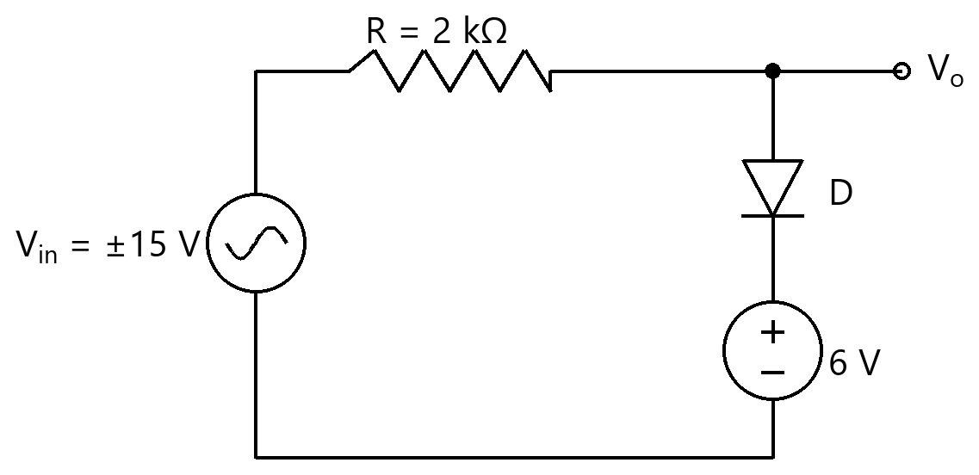
Option | +6 V  +6 V
Option | +5.3 V  +5.3 V
Option | +6.7 V  +6.7 V
Option | +15 V  +15 V
Correct | 3
Explanation | 1. Core Concept & Formula  The shunt diode conducts once the output tries to exceed the battery voltage plus one diode drop, holding the positive peak at Vb + 0.7 V.  $\scriptstyle V_{\text{clip}} = \text{Vb} + 0.7 V$  2. Calculation Steps  $\scriptstyle V_{\text{clip}} = 6 + 0.7 = 6.7 V$  Final Answer: +6.7 V
Subject | Analog Electronics
Topic | Diode and Its Applications (Wave Shaping Circuits)
Correct Marks | 3
Incorrect Marks | 1
Hint | -
Video Solution | -
PYQ
OTS ID | AJEEEANE1530497

Question | 498
Type | MCQ
Body | In the positive shunt clipper shown, a ±8 V peak sine input passes through R = 1 kΩ; the diode (Si, 0.7 V) in series with a 2 V battery clips the output. The positive peak of $\scriptstyle V_o$ is clipped to:  दिखाए गए धनात्मक शंट क्लिपर में, ±8 V शिखर ज्या निवेश R = 1 kΩ से गुजरता है; 2 V बैटरी के श्रेणी में डायोड (Si, 0.7 V) निर्गत को क्लिप करता है। $\scriptstyle V_o$ का धनात्मक शिखर किस पर क्लिप होता है:  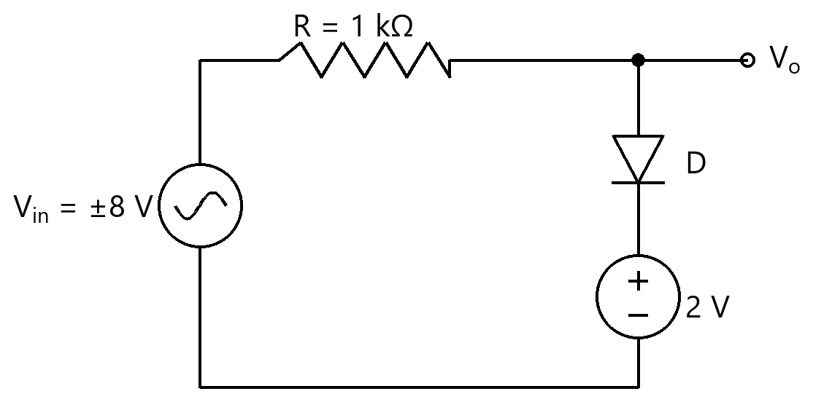
Option | +2 V  +2 V
Option | +1.3 V  +1.3 V
Option | +8 V  +8 V
Option | +2.7 V  +2.7 V
Correct | 4
Explanation | 1. Core Concept & Formula  The shunt diode conducts once the output tries to exceed the battery voltage plus one diode drop, holding the positive peak at Vb + 0.7 V.  $\scriptstyle V_{\text{clip}} = \text{Vb} + 0.7 V$  2. Calculation Steps  $\scriptstyle V_{\text{clip}} = 2 + 0.7 = 2.7 V$  Final Answer: +2.7 V
Subject | Analog Electronics
Topic | Diode and Its Applications (Wave Shaping Circuits)
Correct Marks | 3
Incorrect Marks | 1
Hint | -
Video Solution | -
PYQ
OTS ID | AJEEEANE1530498

Question | 499
Type | MCQ
Body | In the positive shunt clipper shown, a ±20 V peak sine input passes through R = 2 kΩ; the diode (Si, 0.7 V) in series with a 10 V battery clips the output. The positive peak of $\scriptstyle V_o$ is clipped to:  दिखाए गए धनात्मक शंट क्लिपर में, ±20 V शिखर ज्या निवेश R = 2 kΩ से गुजरता है; 10 V बैटरी के श्रेणी में डायोड (Si, 0.7 V) निर्गत को क्लिप करता है। $\scriptstyle V_o$ का धनात्मक शिखर किस पर क्लिप होता है:  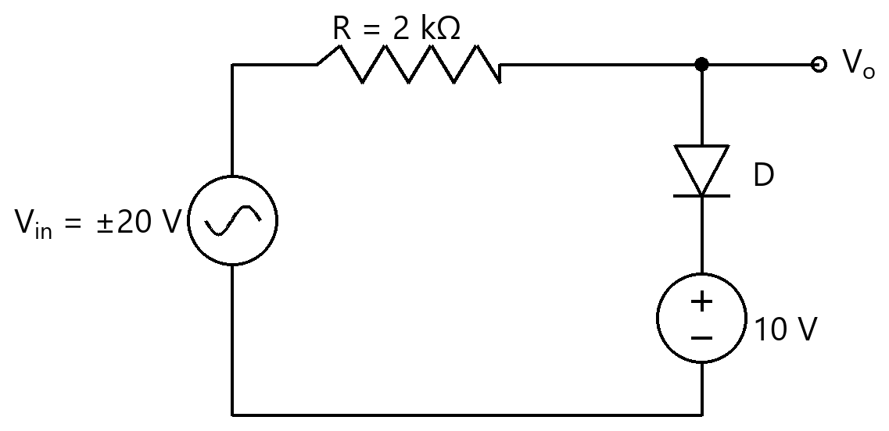
Option | +10.7 V  +10.7 V
Option | +10 V  +10 V
Option | +9.3 V  +9.3 V
Option | +20 V  +20 V
Correct | 1
Explanation | 1. Core Concept & Formula  The shunt diode conducts once the output tries to exceed the battery voltage plus one diode drop, holding the positive peak at Vb + 0.7 V.  $\scriptstyle V_{\text{clip}} = \text{Vb} + 0.7 V$  2. Calculation Steps  $\scriptstyle V_{\text{clip}} = 10 + 0.7 = 10.7 V$  Final Answer: +10.7 V
Subject | Analog Electronics
Topic | Diode and Its Applications (Wave Shaping Circuits)
Correct Marks | 3
Incorrect Marks | 1
Hint | -
Video Solution | -
PYQ
OTS ID | AJEEEANE1530499

Question | 500
Type | MCQ
Body | In the positive shunt clipper shown, a ±10 V peak sine input passes through R = 1 kΩ; the diode (Si, 0.7 V) in series with a 4 V battery clips the output. The positive peak of $\scriptstyle V_o$ is clipped to:  दिखाए गए धनात्मक शंट क्लिपर में, ±10 V शिखर ज्या निवेश R = 1 kΩ से गुजरता है; 4 V बैटरी के श्रेणी में डायोड (Si, 0.7 V) निर्गत को क्लिप करता है। $\scriptstyle V_o$ का धनात्मक शिखर किस पर क्लिप होता है:  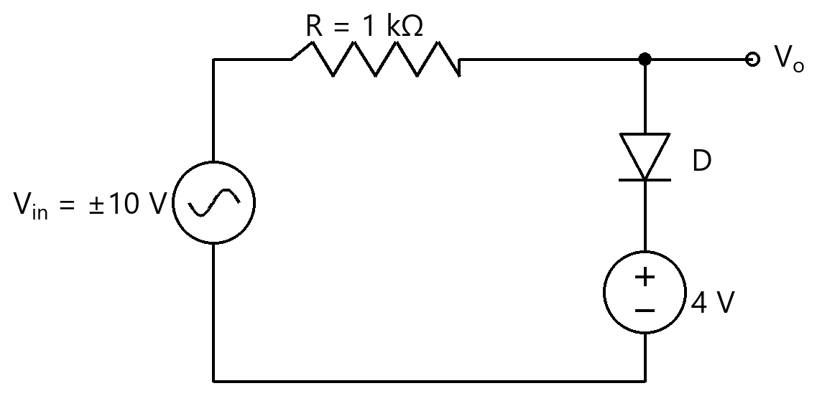
Option | +4 V  +4 V
Option | +4.7 V  +4.7 V
Option | +3.3 V  +3.3 V
Option | +10 V  +10 V
Correct | 2
Explanation | 1. Core Concept & Formula  The shunt diode conducts once the output tries to exceed the battery voltage plus one diode drop, holding the positive peak at Vb + 0.7 V.  $\scriptstyle V_{\text{clip}} = \text{Vb} + 0.7 V$  2. Calculation Steps  $\scriptstyle V_{\text{clip}} = 4 + 0.7 = 4.7 V$  Final Answer: +4.7 V
Subject | Analog Electronics
Topic | Diode and Its Applications (Wave Shaping Circuits)
Correct Marks | 3
Incorrect Marks | 1
Hint | -
Video Solution | -
PYQ
OTS ID | AJEEEANE1530500

Question | 501
Type | MCQ
Body | In the Zener shunt regulator shown, $\scriptstyle V_{in}$ = 20 V, $\scriptstyle R_S$ = 200 Ω, $\scriptstyle V_Z$ = 10 V and $\scriptstyle R_L$ = 1000 Ω. The current through the Zener diode is:  दिखाए गए ज़ेनर शंट रेगुलेटर में, $\scriptstyle V_{in}$ = 20 V, $\scriptstyle R_S$ = 200 Ω, $\scriptstyle V_Z$ = 10 V तथा $\scriptstyle R_L$ = 1000 Ω। ज़ेनर डायोड से होकर धारा है:  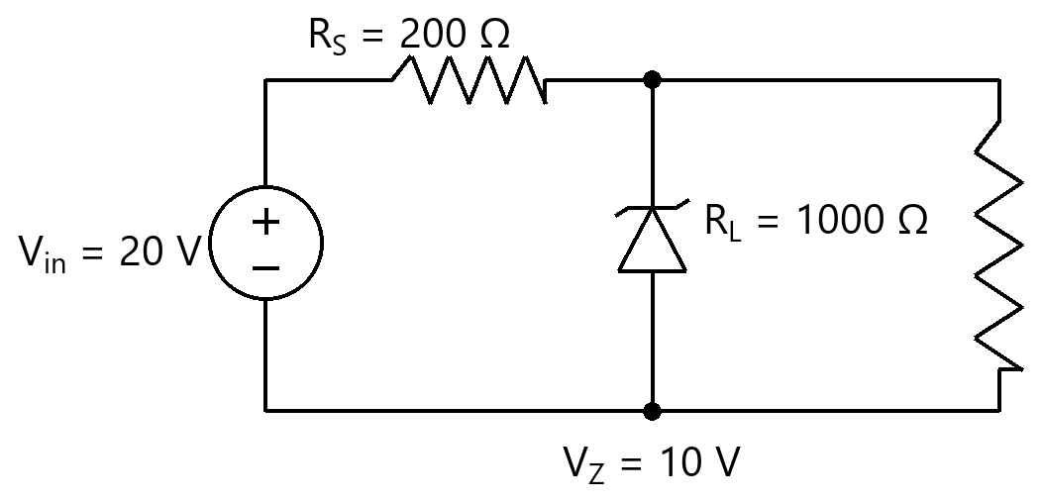
Option | 50.0 mA  50.0 mA
Option | 10.0 mA  10.0 mA
Option | 40.0 mA  40.0 mA
Option | 60.0 mA  60.0 mA
Correct | 3
Explanation | 1. Core Concept & Formula  The series current from $\scriptstyle R_S$ splits between the load and the Zener. $\scriptstyle I_Z$ = $\scriptstyle I_S$ − $\scriptstyle I_L$, with $\scriptstyle I_S$ = ($\scriptstyle V_{in}$−$\scriptstyle V_Z$)/$\scriptstyle R_S$ and $\scriptstyle I_L$ = $\scriptstyle V_Z$/$\scriptstyle R_L$.  $\scriptstyle I_S$ = ($\scriptstyle V_{in}$ − $\scriptstyle V_Z$)/$\scriptstyle R_S$  $\scriptstyle I_L$ = $\scriptstyle V_Z$/$\scriptstyle R_L$  $\scriptstyle I_Z$ = $\scriptstyle I_S$ − $\scriptstyle I_L$  2. Calculation Steps  $\scriptstyle I_S = (20−10)/200 = 50.0 \text{mA}$  $\scriptstyle I_L = 10/1000 = 10.0 \text{mA}$  $\scriptstyle I_Z = 50.0 − 10.0 = 40.0 \text{mA}$  Final Answer: 40.0 mA
Subject | Analog Electronics
Topic | Diode and Its Applications (Voltage Regulator)
Correct Marks | 3
Incorrect Marks | 1
Hint | -
Video Solution | -
PYQ
OTS ID | AJEEEANE1430501

Question | 502
Type | MCQ
Body | In the Zener shunt regulator shown, $\scriptstyle V_{in}$ = 24 V, $\scriptstyle R_S$ = 400 Ω, $\scriptstyle V_Z$ = 12 V and $\scriptstyle R_L$ = 600 Ω. The current through the Zener diode is:  दिखाए गए ज़ेनर शंट रेगुलेटर में, $\scriptstyle V_{in}$ = 24 V, $\scriptstyle R_S$ = 400 Ω, $\scriptstyle V_Z$ = 12 V तथा $\scriptstyle R_L$ = 600 Ω। ज़ेनर डायोड से होकर धारा है:  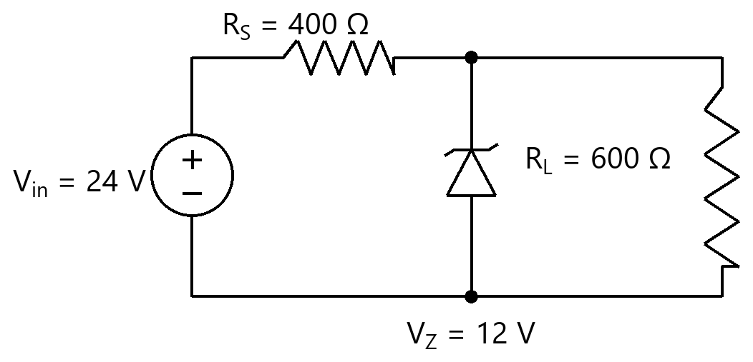
Option | 30.0 mA  30.0 mA
Option | 20.0 mA  20.0 mA
Option | 50.0 mA  50.0 mA
Option | 10.0 mA  10.0 mA
Correct | 4
Explanation | 1. Core Concept & Formula  The series current from $\scriptstyle R_S$ splits between the load and the Zener. $\scriptstyle I_Z$ = $\scriptstyle I_S$ − $\scriptstyle I_L$, with $\scriptstyle I_S$ = ($\scriptstyle V_{in}$−$\scriptstyle V_Z$)/$\scriptstyle R_S$ and $\scriptstyle I_L$ = $\scriptstyle V_Z$/$\scriptstyle R_L$.  $\scriptstyle I_S$ = ($\scriptstyle V_{in}$ − $\scriptstyle V_Z$)/$\scriptstyle R_S$  $\scriptstyle I_L$ = $\scriptstyle V_Z$/$\scriptstyle R_L$  $\scriptstyle I_Z$ = $\scriptstyle I_S$ − $\scriptstyle I_L$  2. Calculation Steps  $\scriptstyle I_S = (24−12)/400 = 30.0 \text{mA}$  $\scriptstyle I_L = 12/600 = 20.0 \text{mA}$  $\scriptstyle I_Z = 30.0 − 20.0 = 10.0 \text{mA}$  Final Answer: 10.0 mA
Subject | Analog Electronics
Topic | Diode and Its Applications (Voltage Regulator)
Correct Marks | 3
Incorrect Marks | 1
Hint | -
Video Solution | -
PYQ
OTS ID | AJEEEANE1430502

Question | 503
Type | MCQ
Body | In the Zener shunt regulator shown, $\scriptstyle V_{in}$ = 15 V, $\scriptstyle R_S$ = 100 Ω, $\scriptstyle V_Z$ = 9 V and $\scriptstyle R_L$ = 900 Ω. The current through the Zener diode is:  दिखाए गए ज़ेनर शंट रेगुलेटर में, $\scriptstyle V_{in}$ = 15 V, $\scriptstyle R_S$ = 100 Ω, $\scriptstyle V_Z$ = 9 V तथा $\scriptstyle R_L$ = 900 Ω। ज़ेनर डायोड से होकर धारा है:  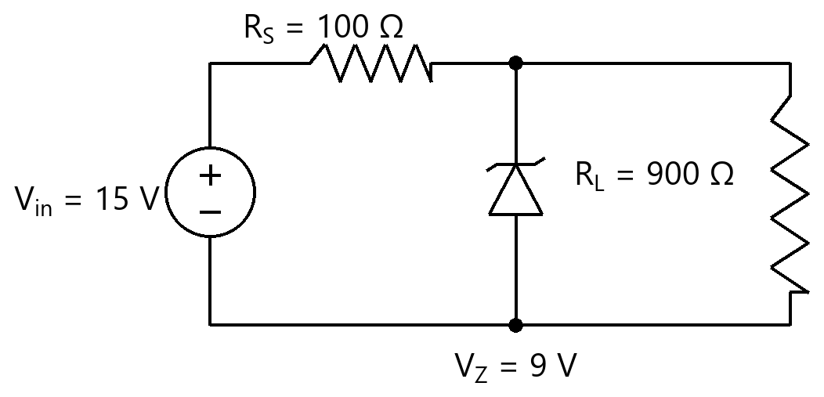
Option | 50.0 mA  50.0 mA
Option | 60.0 mA  60.0 mA
Option | 10.0 mA  10.0 mA
Option | 70.0 mA  70.0 mA
Correct | 1
Explanation | 1. Core Concept & Formula  The series current from $\scriptstyle R_S$ splits between the load and the Zener. $\scriptstyle I_Z$ = $\scriptstyle I_S$ − $\scriptstyle I_L$, with $\scriptstyle I_S$ = ($\scriptstyle V_{in}$−$\scriptstyle V_Z$)/$\scriptstyle R_S$ and $\scriptstyle I_L$ = $\scriptstyle V_Z$/$\scriptstyle R_L$.  $\scriptstyle I_S$ = ($\scriptstyle V_{in}$ − $\scriptstyle V_Z$)/$\scriptstyle R_S$  $\scriptstyle I_L$ = $\scriptstyle V_Z$/$\scriptstyle R_L$  $\scriptstyle I_Z$ = $\scriptstyle I_S$ − $\scriptstyle I_L$  2. Calculation Steps  $\scriptstyle I_S = (15−9)/100 = 60.0 \text{mA}$  $\scriptstyle I_L = 9/900 = 10.0 \text{mA}$  $\scriptstyle I_Z = 60.0 − 10.0 = 50.0 \text{mA}$  Final Answer: 50.0 mA
Subject | Analog Electronics
Topic | Diode and Its Applications (Voltage Regulator)
Correct Marks | 3
Incorrect Marks | 1
Hint | -
Video Solution | -
PYQ
OTS ID | AJEEEANE1430503

Question | 504
Type | MCQ
Body | In the Zener shunt regulator shown, $\scriptstyle V_{in}$ = 18 V, $\scriptstyle R_S$ = 300 Ω, $\scriptstyle V_Z$ = 12 V and $\scriptstyle R_L$ = 1200 Ω. The current through the Zener diode is:  दिखाए गए ज़ेनर शंट रेगुलेटर में, $\scriptstyle V_{in}$ = 18 V, $\scriptstyle R_S$ = 300 Ω, $\scriptstyle V_Z$ = 12 V तथा $\scriptstyle R_L$ = 1200 Ω। ज़ेनर डायोड से होकर धारा है:  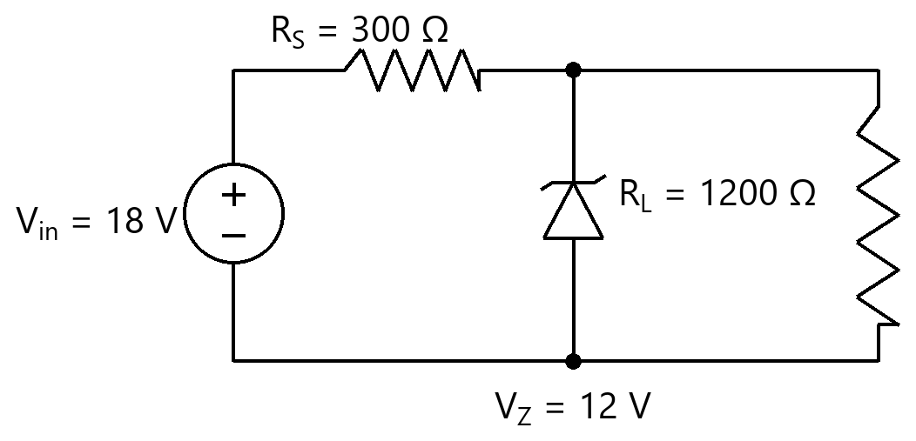
Option | 20.0 mA  20.0 mA
Option | 10.0 mA  10.0 mA
Option | 60.0 mA  60.0 mA
Option | 30.0 mA  30.0 mA
Correct | 2
Explanation | 1. Core Concept & Formula  The series current from $\scriptstyle R_S$ splits between the load and the Zener. $\scriptstyle I_Z$ = $\scriptstyle I_S$ − $\scriptstyle I_L$, with $\scriptstyle I_S$ = ($\scriptstyle V_{in}$−$\scriptstyle V_Z$)/$\scriptstyle R_S$ and $\scriptstyle I_L$ = $\scriptstyle V_Z$/$\scriptstyle R_L$.  $\scriptstyle I_S$ = ($\scriptstyle V_{in}$ − $\scriptstyle V_Z$)/$\scriptstyle R_S$  $\scriptstyle I_L$ = $\scriptstyle V_Z$/$\scriptstyle R_L$  $\scriptstyle I_Z$ = $\scriptstyle I_S$ − $\scriptstyle I_L$  2. Calculation Steps  $\scriptstyle I_S = (18−12)/300 = 20.0 \text{mA}$  $\scriptstyle I_L = 12/1200 = 10.0 \text{mA}$  $\scriptstyle I_Z = 20.0 − 10.0 = 10.0 \text{mA}$  Final Answer: 10.0 mA
Subject | Analog Electronics
Topic | Diode and Its Applications (Voltage Regulator)
Correct Marks | 3
Incorrect Marks | 1
Hint | -
Video Solution | -
PYQ
OTS ID | AJEEEANE1430504

Question | 505
Type | MCQ
Body | In the Zener shunt regulator shown, $\scriptstyle V_{in}$ = 30 V, $\scriptstyle R_S$ = 500 Ω, $\scriptstyle V_Z$ = 15 V and $\scriptstyle R_L$ = 1500 Ω. The current through the Zener diode is:  दिखाए गए ज़ेनर शंट रेगुलेटर में, $\scriptstyle V_{in}$ = 30 V, $\scriptstyle R_S$ = 500 Ω, $\scriptstyle V_Z$ = 15 V तथा $\scriptstyle R_L$ = 1500 Ω। ज़ेनर डायोड से होकर धारा है:  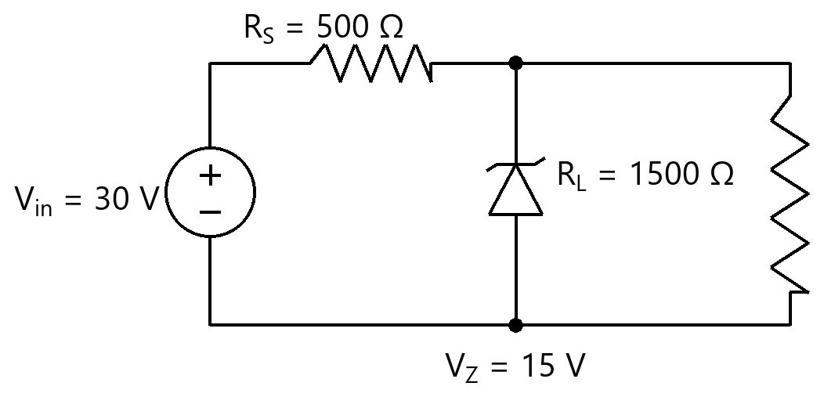
Option | 30.0 mA  30.0 mA
Option | 10.0 mA  10.0 mA
Option | 20.0 mA  20.0 mA
Option | 40.0 mA  40.0 mA
Correct | 3
Explanation | 1. Core Concept & Formula  The series current from $\scriptstyle R_S$ splits between the load and the Zener. $\scriptstyle I_Z$ = $\scriptstyle I_S$ − $\scriptstyle I_L$, with $\scriptstyle I_S$ = ($\scriptstyle V_{in}$−$\scriptstyle V_Z$)/$\scriptstyle R_S$ and $\scriptstyle I_L$ = $\scriptstyle V_Z$/$\scriptstyle R_L$.  $\scriptstyle I_S$ = ($\scriptstyle V_{in}$ − $\scriptstyle V_Z$)/$\scriptstyle R_S$  $\scriptstyle I_L$ = $\scriptstyle V_Z$/$\scriptstyle R_L$  $\scriptstyle I_Z$ = $\scriptstyle I_S$ − $\scriptstyle I_L$  2. Calculation Steps  $\scriptstyle I_S = (30−15)/500 = 30.0 \text{mA}$  $\scriptstyle I_L = 15/1500 = 10.0 \text{mA}$  $\scriptstyle I_Z = 30.0 − 10.0 = 20.0 \text{mA}$  Final Answer: 20.0 mA
Subject | Analog Electronics
Topic | Diode and Its Applications (Voltage Regulator)
Correct Marks | 3
Incorrect Marks | 1
Hint | -
Video Solution | -
PYQ
OTS ID | AJEEEANE1430505

Question | 506
Type | MCQ
Body | In the Zener shunt regulator shown, $\scriptstyle V_{in}$ = 12 V, $\scriptstyle R_S$ = 100 Ω, $\scriptstyle V_Z$ = 6 V and $\scriptstyle R_L$ = 300 Ω. The current through the Zener diode is:  दिखाए गए ज़ेनर शंट रेगुलेटर में, $\scriptstyle V_{in}$ = 12 V, $\scriptstyle R_S$ = 100 Ω, $\scriptstyle V_Z$ = 6 V तथा $\scriptstyle R_L$ = 300 Ω। ज़ेनर डायोड से होकर धारा है:  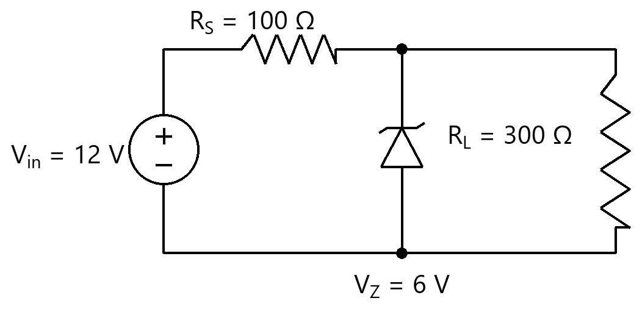
Option | 60.0 mA  60.0 mA
Option | 20.0 mA  20.0 mA
Option | 80.0 mA  80.0 mA
Option | 40.0 mA  40.0 mA
Correct | 4
Explanation | 1. Core Concept & Formula  The series current from $\scriptstyle R_S$ splits between the load and the Zener. $\scriptstyle I_Z$ = $\scriptstyle I_S$ − $\scriptstyle I_L$, with $\scriptstyle I_S$ = ($\scriptstyle V_{in}$−$\scriptstyle V_Z$)/$\scriptstyle R_S$ and $\scriptstyle I_L$ = $\scriptstyle V_Z$/$\scriptstyle R_L$.  $\scriptstyle I_S$ = ($\scriptstyle V_{in}$ − $\scriptstyle V_Z$)/$\scriptstyle R_S$  $\scriptstyle I_L$ = $\scriptstyle V_Z$/$\scriptstyle R_L$  $\scriptstyle I_Z$ = $\scriptstyle I_S$ − $\scriptstyle I_L$  2. Calculation Steps  $\scriptstyle I_S = (12−6)/100 = 60.0 \text{mA}$  $\scriptstyle I_L = 6/300 = 20.0 \text{mA}$  $\scriptstyle I_Z = 60.0 − 20.0 = 40.0 \text{mA}$  Final Answer: 40.0 mA
Subject | Analog Electronics
Topic | Diode and Its Applications (Voltage Regulator)
Correct Marks | 3
Incorrect Marks | 1
Hint | -
Video Solution | -
PYQ
OTS ID | AJEEEANE1430506

Question | 507
Type | MCQ
Body | For the voltage-divider biased npn stage shown ($\scriptstyle V_{CC}$ = 12 V, $\scriptstyle R_1$ = 40 kΩ, $\scriptstyle R_2$ = 10 kΩ, $\scriptstyle R_C$ = 2 kΩ, $\scriptstyle R_E$ = 1 kΩ, $\scriptstyle V_{BE}$ = 0.7 V, large β), the Q-point ($\scriptstyle I_C$, $\scriptstyle V_{CE}$) is approximately:  दिखाए गए वोल्टेज-विभाजक बायस npn चरण के लिए ($\scriptstyle V_{CC}$ = 12 V, $\scriptstyle R_1$ = 40 kΩ, $\scriptstyle R_2$ = 10 kΩ, $\scriptstyle R_C$ = 2 kΩ, $\scriptstyle R_E$ = 1 kΩ, $\scriptstyle V_{BE}$ = 0.7 V, बड़ा β), Q-बिंदु ($\scriptstyle I_C$, $\scriptstyle V_{CE}$) लगभग है:  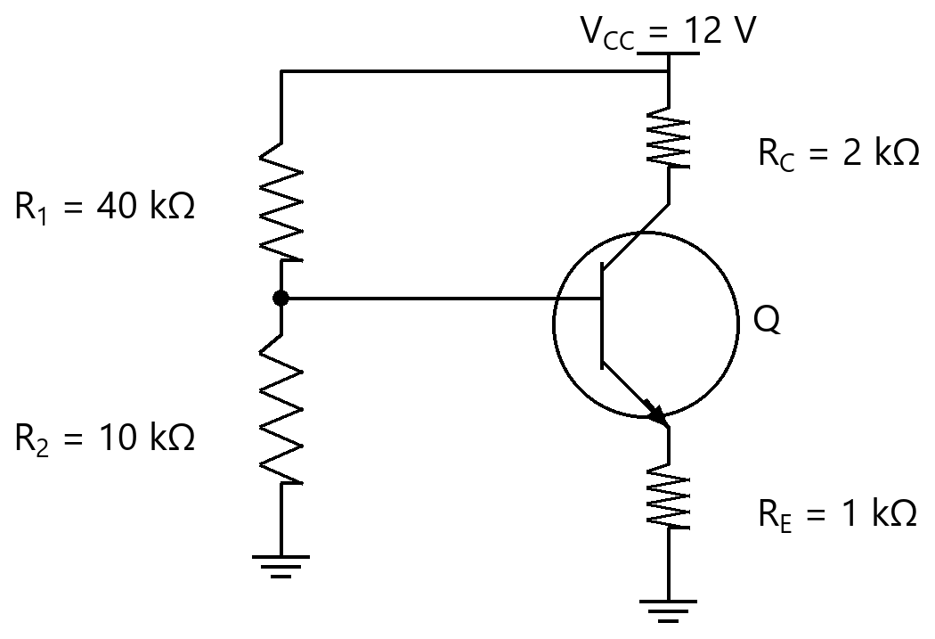
Option | $\scriptstyle I_C$ ≈ 1.7 mA, $\scriptstyle V_{CE}$ ≈ 6.9 V  $\scriptstyle I_C$ ≈ 1.7 mA, $\scriptstyle V_{CE}$ ≈ 6.9 V
Option | $\scriptstyle I_C$ ≈ 2.4 mA, $\scriptstyle V_{CE}$ ≈ 6.9 V  $\scriptstyle I_C$ ≈ 2.4 mA, $\scriptstyle V_{CE}$ ≈ 6.9 V
Option | $\scriptstyle I_C$ ≈ 1.7 mA, $\scriptstyle V_{CE}$ ≈ 8.6 V  $\scriptstyle I_C$ ≈ 1.7 mA, $\scriptstyle V_{CE}$ ≈ 8.6 V
Option | $\scriptstyle I_C$ ≈ 2.55 mA, $\scriptstyle V_{CE}$ ≈ 6.9 V  $\scriptstyle I_C$ ≈ 2.55 mA, $\scriptstyle V_{CE}$ ≈ 6.9 V
Correct | 1
Explanation | 1. Core Concept & Formula  Thevenin the base divider: $\scriptstyle V_B$ = $\scriptstyle V_{CC}$·$\scriptstyle R_2$/($\scriptstyle R_1$+$\scriptstyle R_2$); $\scriptstyle V_E$ = $\scriptstyle V_B$ − 0.7; $\scriptstyle I_C$ ≈ $\scriptstyle I_E$ = $\scriptstyle V_E$/$\scriptstyle R_E$; $\scriptstyle V_{CE}$ = $\scriptstyle V_{CC}$ − $\scriptstyle I_C$($\scriptstyle R_C$+$\scriptstyle R_E$).  $\scriptstyle V_B = V_{CC}\cdot R_2/(R_1+R_2)$  $\scriptstyle I_C$ ≈ ($\scriptstyle V_B$ − 0.7)/$\scriptstyle R_E$  $\scriptstyle V_{CE}$ = $\scriptstyle V_{CC}$ − $\scriptstyle I_C$($\scriptstyle R_C$+$\scriptstyle R_E$)  2. Calculation Steps  $\scriptstyle V_B = 12×10/(40+10) = 2.4 V$  $\scriptstyle I_C ≈ (2.4 − 0.7)/1 = 1.7 \text{mA}$  $\scriptstyle V_{CE} = 12 − 1.7×(2+1) = 6.9 V$  Final Answer: $\scriptstyle I_C$ ≈ 1.7 mA, $\scriptstyle V_{CE}$ ≈ 6.9 V
Subject | Analog Electronics
Topic | BJT (DC Analysis and Biasing Circuits of BJT)
Correct Marks | 3
Incorrect Marks | 1
Hint | -
Video Solution | -
PYQ
OTS ID | AJEEEANE2130507

Question | 508
Type | MCQ
Body | For the voltage-divider biased npn stage shown ($\scriptstyle V_{CC}$ = 15 V, $\scriptstyle R_1$ = 47 kΩ, $\scriptstyle R_2$ = 10 kΩ, $\scriptstyle R_C$ = 3 kΩ, $\scriptstyle R_E$ = 1 kΩ, $\scriptstyle V_{BE}$ = 0.7 V, large β), the Q-point ($\scriptstyle I_C$, $\scriptstyle V_{CE}$) is approximately:  दिखाए गए वोल्टेज-विभाजक बायस npn चरण के लिए ($\scriptstyle V_{CC}$ = 15 V, $\scriptstyle R_1$ = 47 kΩ, $\scriptstyle R_2$ = 10 kΩ, $\scriptstyle R_C$ = 3 kΩ, $\scriptstyle R_E$ = 1 kΩ, $\scriptstyle V_{BE}$ = 0.7 V, बड़ा β), Q-बिंदु ($\scriptstyle I_C$, $\scriptstyle V_{CE}$) लगभग है:  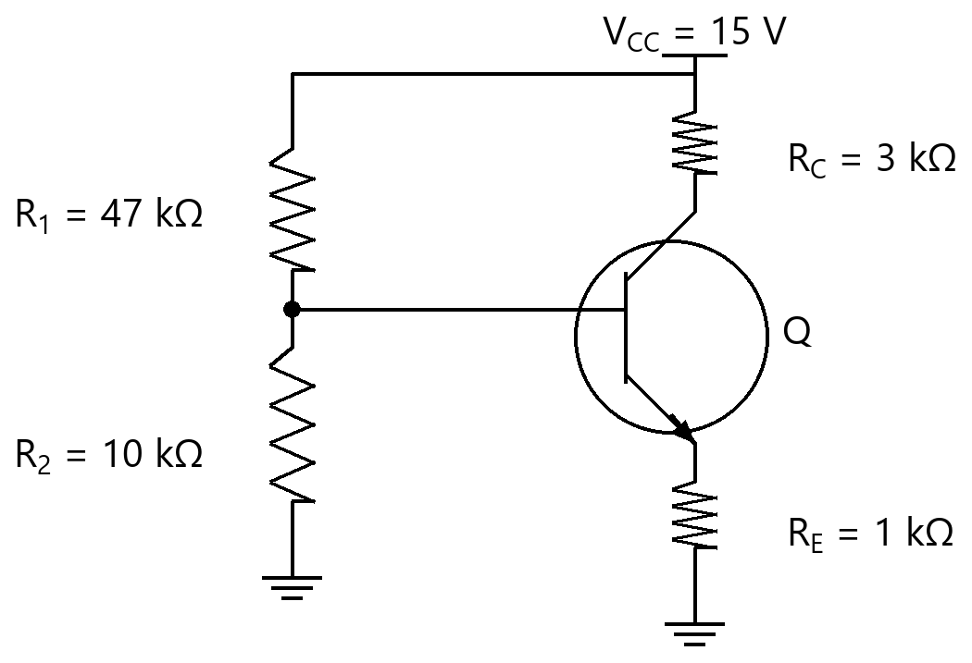
Option | $\scriptstyle I_C$ ≈ 2.63 mA, $\scriptstyle V_{CE}$ ≈ 7.28 V  $\scriptstyle I_C$ ≈ 2.63 mA, $\scriptstyle V_{CE}$ ≈ 7.28 V
Option | $\scriptstyle I_C$ ≈ 1.93 mA, $\scriptstyle V_{CE}$ ≈ 7.28 V  $\scriptstyle I_C$ ≈ 1.93 mA, $\scriptstyle V_{CE}$ ≈ 7.28 V
Option | $\scriptstyle I_C$ ≈ 1.93 mA, $\scriptstyle V_{CE}$ ≈ 9.21 V  $\scriptstyle I_C$ ≈ 1.93 mA, $\scriptstyle V_{CE}$ ≈ 9.21 V
Option | $\scriptstyle I_C$ ≈ 2.9 mA, $\scriptstyle V_{CE}$ ≈ 7.28 V  $\scriptstyle I_C$ ≈ 2.9 mA, $\scriptstyle V_{CE}$ ≈ 7.28 V
Correct | 2
Explanation | 1. Core Concept & Formula  Thevenin the base divider: $\scriptstyle V_B$ = $\scriptstyle V_{CC}$·$\scriptstyle R_2$/($\scriptstyle R_1$+$\scriptstyle R_2$); $\scriptstyle V_E$ = $\scriptstyle V_B$ − 0.7; $\scriptstyle I_C$ ≈ $\scriptstyle I_E$ = $\scriptstyle V_E$/$\scriptstyle R_E$; $\scriptstyle V_{CE}$ = $\scriptstyle V_{CC}$ − $\scriptstyle I_C$($\scriptstyle R_C$+$\scriptstyle R_E$).  $\scriptstyle V_B = V_{CC}\cdot R_2/(R_1+R_2)$  $\scriptstyle I_C$ ≈ ($\scriptstyle V_B$ − 0.7)/$\scriptstyle R_E$  $\scriptstyle V_{CE}$ = $\scriptstyle V_{CC}$ − $\scriptstyle I_C$($\scriptstyle R_C$+$\scriptstyle R_E$)  2. Calculation Steps  $\scriptstyle V_B = 15×10/(47+10) = 2.63 V$  $\scriptstyle I_C ≈ (2.63 − 0.7)/1 = 1.93 \text{mA}$  $\scriptstyle V_{CE} = 15 − 1.93×(3+1) = 7.28 V$  Final Answer: $\scriptstyle I_C$ ≈ 1.93 mA, $\scriptstyle V_{CE}$ ≈ 7.28 V
Subject | Analog Electronics
Topic | BJT (DC Analysis and Biasing Circuits of BJT)
Correct Marks | 3
Incorrect Marks | 1
Hint | -
Video Solution | -
PYQ
OTS ID | AJEEEANE2130508

Question | 509
Type | MCQ
Body | For the voltage-divider biased npn stage shown ($\scriptstyle V_{CC}$ = 10 V, $\scriptstyle R_1$ = 30 kΩ, $\scriptstyle R_2$ = 10 kΩ, $\scriptstyle R_C$ = 1 kΩ, $\scriptstyle R_E$ = 0.5 kΩ, $\scriptstyle V_{BE}$ = 0.7 V, large β), the Q-point ($\scriptstyle I_C$, $\scriptstyle V_{CE}$) is approximately:  दिखाए गए वोल्टेज-विभाजक बायस npn चरण के लिए ($\scriptstyle V_{CC}$ = 10 V, $\scriptstyle R_1$ = 30 kΩ, $\scriptstyle R_2$ = 10 kΩ, $\scriptstyle R_C$ = 1 kΩ, $\scriptstyle R_E$ = 0.5 kΩ, $\scriptstyle V_{BE}$ = 0.7 V, बड़ा β), Q-बिंदु ($\scriptstyle I_C$, $\scriptstyle V_{CE}$) लगभग है:  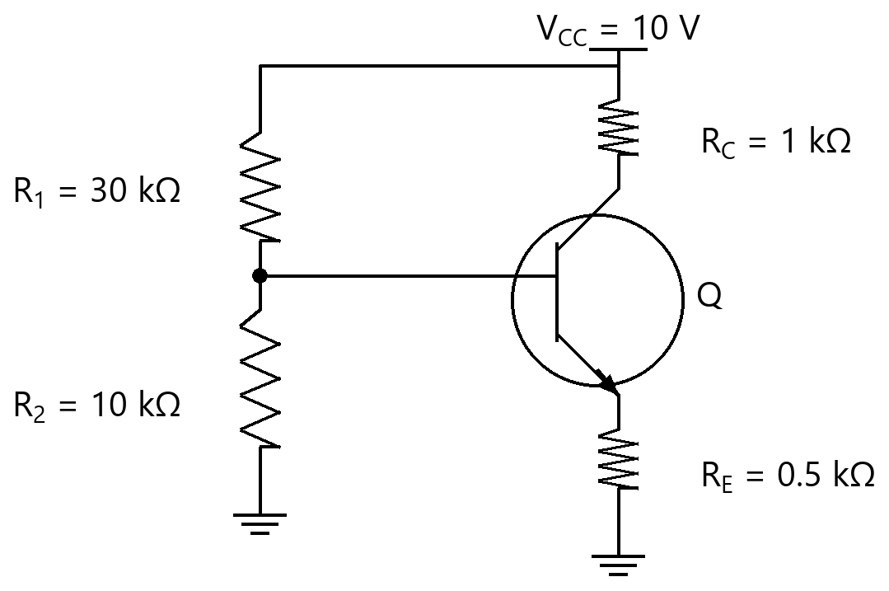
Option | $\scriptstyle I_C$ ≈ 5.0 mA, $\scriptstyle V_{CE}$ ≈ 4.6 V  $\scriptstyle I_C$ ≈ 5.0 mA, $\scriptstyle V_{CE}$ ≈ 4.6 V
Option | $\scriptstyle I_C$ ≈ 3.6 mA, $\scriptstyle V_{CE}$ ≈ 6.4 V  $\scriptstyle I_C$ ≈ 3.6 mA, $\scriptstyle V_{CE}$ ≈ 6.4 V
Option | $\scriptstyle I_C$ ≈ 3.6 mA, $\scriptstyle V_{CE}$ ≈ 4.6 V  $\scriptstyle I_C$ ≈ 3.6 mA, $\scriptstyle V_{CE}$ ≈ 4.6 V
Option | $\scriptstyle I_C$ ≈ 5.4 mA, $\scriptstyle V_{CE}$ ≈ 4.6 V  $\scriptstyle I_C$ ≈ 5.4 mA, $\scriptstyle V_{CE}$ ≈ 4.6 V
Correct | 3
Explanation | 1. Core Concept & Formula  Thevenin the base divider: $\scriptstyle V_B$ = $\scriptstyle V_{CC}$·$\scriptstyle R_2$/($\scriptstyle R_1$+$\scriptstyle R_2$); $\scriptstyle V_E$ = $\scriptstyle V_B$ − 0.7; $\scriptstyle I_C$ ≈ $\scriptstyle I_E$ = $\scriptstyle V_E$/$\scriptstyle R_E$; $\scriptstyle V_{CE}$ = $\scriptstyle V_{CC}$ − $\scriptstyle I_C$($\scriptstyle R_C$+$\scriptstyle R_E$).  $\scriptstyle V_B = V_{CC}\cdot R_2/(R_1+R_2)$  $\scriptstyle I_C$ ≈ ($\scriptstyle V_B$ − 0.7)/$\scriptstyle R_E$  $\scriptstyle V_{CE}$ = $\scriptstyle V_{CC}$ − $\scriptstyle I_C$($\scriptstyle R_C$+$\scriptstyle R_E$)  2. Calculation Steps  $\scriptstyle V_B = 10×10/(30+10) = 2.5 V$  $\scriptstyle I_C ≈ (2.5 − 0.7)/0.5 = 3.6 \text{mA}$  $\scriptstyle V_{CE} = 10 − 3.6×(1+0.5) = 4.6 V$  Final Answer: $\scriptstyle I_C$ ≈ 3.6 mA, $\scriptstyle V_{CE}$ ≈ 4.6 V
Subject | Analog Electronics
Topic | BJT (DC Analysis and Biasing Circuits of BJT)
Correct Marks | 3
Incorrect Marks | 1
Hint | -
Video Solution | -
PYQ
OTS ID | AJEEEANE2130509

Question | 510
Type | MCQ
Body | For the voltage-divider biased npn stage shown ($\scriptstyle V_{CC}$ = 18 V, $\scriptstyle R_1$ = 50 kΩ, $\scriptstyle R_2$ = 10 kΩ, $\scriptstyle R_C$ = 4 kΩ, $\scriptstyle R_E$ = 1 kΩ, $\scriptstyle V_{BE}$ = 0.7 V, large β), the Q-point ($\scriptstyle I_C$, $\scriptstyle V_{CE}$) is approximately:  दिखाए गए वोल्टेज-विभाजक बायस npn चरण के लिए ($\scriptstyle V_{CC}$ = 18 V, $\scriptstyle R_1$ = 50 kΩ, $\scriptstyle R_2$ = 10 kΩ, $\scriptstyle R_C$ = 4 kΩ, $\scriptstyle R_E$ = 1 kΩ, $\scriptstyle V_{BE}$ = 0.7 V, बड़ा β), Q-बिंदु ($\scriptstyle I_C$, $\scriptstyle V_{CE}$) लगभग है:  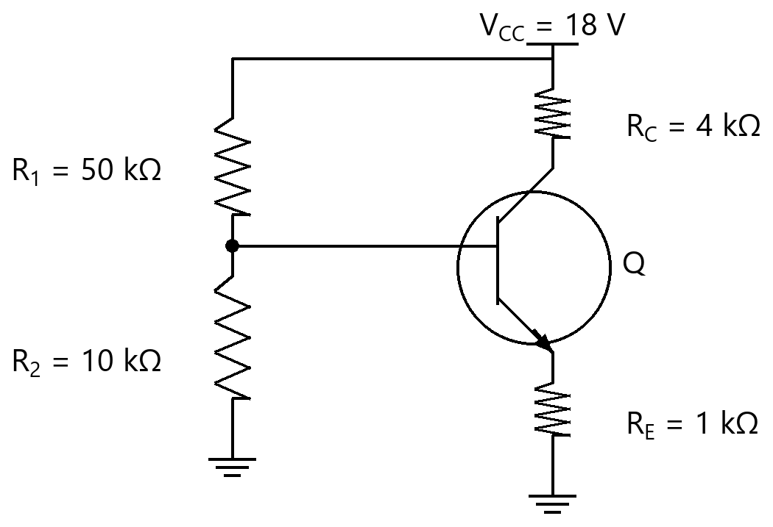
Option | $\scriptstyle I_C$ ≈ 3.0 mA, $\scriptstyle V_{CE}$ ≈ 6.5 V  $\scriptstyle I_C$ ≈ 3.0 mA, $\scriptstyle V_{CE}$ ≈ 6.5 V
Option | $\scriptstyle I_C$ ≈ 2.3 mA, $\scriptstyle V_{CE}$ ≈ 8.8 V  $\scriptstyle I_C$ ≈ 2.3 mA, $\scriptstyle V_{CE}$ ≈ 8.8 V
Option | $\scriptstyle I_C$ ≈ 3.45 mA, $\scriptstyle V_{CE}$ ≈ 6.5 V  $\scriptstyle I_C$ ≈ 3.45 mA, $\scriptstyle V_{CE}$ ≈ 6.5 V
Option | $\scriptstyle I_C$ ≈ 2.3 mA, $\scriptstyle V_{CE}$ ≈ 6.5 V  $\scriptstyle I_C$ ≈ 2.3 mA, $\scriptstyle V_{CE}$ ≈ 6.5 V
Correct | 4
Explanation | 1. Core Concept & Formula  Thevenin the base divider: $\scriptstyle V_B$ = $\scriptstyle V_{CC}$·$\scriptstyle R_2$/($\scriptstyle R_1$+$\scriptstyle R_2$); $\scriptstyle V_E$ = $\scriptstyle V_B$ − 0.7; $\scriptstyle I_C$ ≈ $\scriptstyle I_E$ = $\scriptstyle V_E$/$\scriptstyle R_E$; $\scriptstyle V_{CE}$ = $\scriptstyle V_{CC}$ − $\scriptstyle I_C$($\scriptstyle R_C$+$\scriptstyle R_E$).  $\scriptstyle V_B = V_{CC}\cdot R_2/(R_1+R_2)$  $\scriptstyle I_C$ ≈ ($\scriptstyle V_B$ − 0.7)/$\scriptstyle R_E$  $\scriptstyle V_{CE}$ = $\scriptstyle V_{CC}$ − $\scriptstyle I_C$($\scriptstyle R_C$+$\scriptstyle R_E$)  2. Calculation Steps  $\scriptstyle V_B = 18×10/(50+10) = 3.0 V$  $\scriptstyle I_C ≈ (3.0 − 0.7)/1 = 2.3 \text{mA}$  $\scriptstyle V_{CE} = 18 − 2.3×(4+1) = 6.5 V$  Final Answer: $\scriptstyle I_C$ ≈ 2.3 mA, $\scriptstyle V_{CE}$ ≈ 6.5 V
Subject | Analog Electronics
Topic | BJT (DC Analysis and Biasing Circuits of BJT)
Correct Marks | 3
Incorrect Marks | 1
Hint | -
Video Solution | -
PYQ
OTS ID | AJEEEANE2130510

Question | 511
Type | MCQ
Body | For the voltage-divider biased npn stage shown ($\scriptstyle V_{CC}$ = 12 V, $\scriptstyle R_1$ = 33 kΩ, $\scriptstyle R_2$ = 10 kΩ, $\scriptstyle R_C$ = 2 kΩ, $\scriptstyle R_E$ = 1 kΩ, $\scriptstyle V_{BE}$ = 0.7 V, large β), the Q-point ($\scriptstyle I_C$, $\scriptstyle V_{CE}$) is approximately:  दिखाए गए वोल्टेज-विभाजक बायस npn चरण के लिए ($\scriptstyle V_{CC}$ = 12 V, $\scriptstyle R_1$ = 33 kΩ, $\scriptstyle R_2$ = 10 kΩ, $\scriptstyle R_C$ = 2 kΩ, $\scriptstyle R_E$ = 1 kΩ, $\scriptstyle V_{BE}$ = 0.7 V, बड़ा β), Q-बिंदु ($\scriptstyle I_C$, $\scriptstyle V_{CE}$) लगभग है:  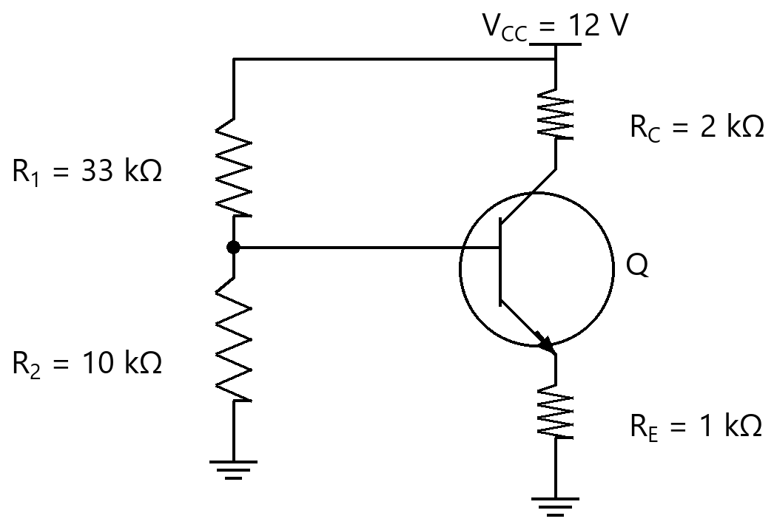
Option | $\scriptstyle I_C$ ≈ 2.09 mA, $\scriptstyle V_{CE}$ ≈ 5.73 V  $\scriptstyle I_C$ ≈ 2.09 mA, $\scriptstyle V_{CE}$ ≈ 5.73 V
Option | $\scriptstyle I_C$ ≈ 2.79 mA, $\scriptstyle V_{CE}$ ≈ 5.73 V  $\scriptstyle I_C$ ≈ 2.79 mA, $\scriptstyle V_{CE}$ ≈ 5.73 V
Option | $\scriptstyle I_C$ ≈ 2.09 mA, $\scriptstyle V_{CE}$ ≈ 7.82 V  $\scriptstyle I_C$ ≈ 2.09 mA, $\scriptstyle V_{CE}$ ≈ 7.82 V
Option | $\scriptstyle I_C$ ≈ 3.14 mA, $\scriptstyle V_{CE}$ ≈ 5.73 V  $\scriptstyle I_C$ ≈ 3.14 mA, $\scriptstyle V_{CE}$ ≈ 5.73 V
Correct | 1
Explanation | 1. Core Concept & Formula  Thevenin the base divider: $\scriptstyle V_B$ = $\scriptstyle V_{CC}$·$\scriptstyle R_2$/($\scriptstyle R_1$+$\scriptstyle R_2$); $\scriptstyle V_E$ = $\scriptstyle V_B$ − 0.7; $\scriptstyle I_C$ ≈ $\scriptstyle I_E$ = $\scriptstyle V_E$/$\scriptstyle R_E$; $\scriptstyle V_{CE}$ = $\scriptstyle V_{CC}$ − $\scriptstyle I_C$($\scriptstyle R_C$+$\scriptstyle R_E$).  $\scriptstyle V_B = V_{CC}\cdot R_2/(R_1+R_2)$  $\scriptstyle I_C$ ≈ ($\scriptstyle V_B$ − 0.7)/$\scriptstyle R_E$  $\scriptstyle V_{CE}$ = $\scriptstyle V_{CC}$ − $\scriptstyle I_C$($\scriptstyle R_C$+$\scriptstyle R_E$)  2. Calculation Steps  $\scriptstyle V_B = 12×10/(33+10) = 2.79 V$  $\scriptstyle I_C ≈ (2.79 − 0.7)/1 = 2.09 \text{mA}$  $\scriptstyle V_{CE} = 12 − 2.09×(2+1) = 5.73 V$  Final Answer: $\scriptstyle I_C$ ≈ 2.09 mA, $\scriptstyle V_{CE}$ ≈ 5.73 V
Subject | Analog Electronics
Topic | BJT (DC Analysis and Biasing Circuits of BJT)
Correct Marks | 3
Incorrect Marks | 1
Hint | -
Video Solution | -
PYQ
OTS ID | AJEEEANE2130511

Question | 512
Type | MCQ
Body | For the voltage-divider biased npn stage shown ($\scriptstyle V_{CC}$ = 20 V, $\scriptstyle R_1$ = 60 kΩ, $\scriptstyle R_2$ = 12 kΩ, $\scriptstyle R_C$ = 3 kΩ, $\scriptstyle R_E$ = 1.2 kΩ, $\scriptstyle V_{BE}$ = 0.7 V, large β), the Q-point ($\scriptstyle I_C$, $\scriptstyle V_{CE}$) is approximately:  दिखाए गए वोल्टेज-विभाजक बायस npn चरण के लिए ($\scriptstyle V_{CC}$ = 20 V, $\scriptstyle R_1$ = 60 kΩ, $\scriptstyle R_2$ = 12 kΩ, $\scriptstyle R_C$ = 3 kΩ, $\scriptstyle R_E$ = 1.2 kΩ, $\scriptstyle V_{BE}$ = 0.7 V, बड़ा β), Q-बिंदु ($\scriptstyle I_C$, $\scriptstyle V_{CE}$) लगभग है:  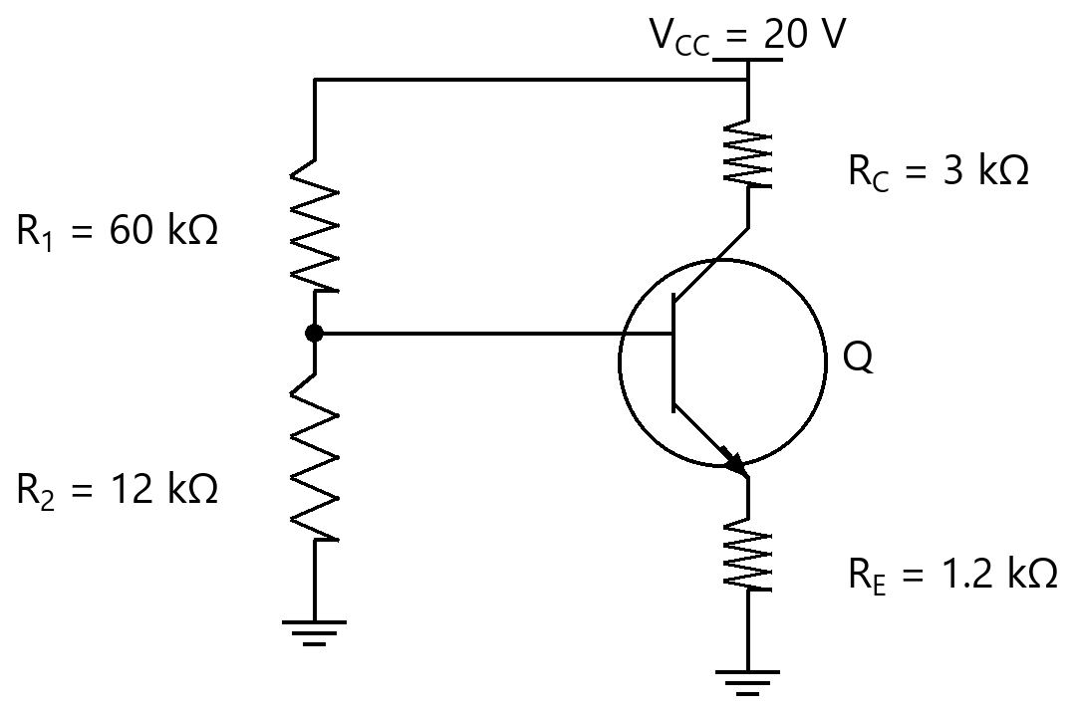
Option | $\scriptstyle I_C$ ≈ 2.78 mA, $\scriptstyle V_{CE}$ ≈ 10.8 V  $\scriptstyle I_C$ ≈ 2.78 mA, $\scriptstyle V_{CE}$ ≈ 10.8 V
Option | $\scriptstyle I_C$ ≈ 2.19 mA, $\scriptstyle V_{CE}$ ≈ 10.8 V  $\scriptstyle I_C$ ≈ 2.19 mA, $\scriptstyle V_{CE}$ ≈ 10.8 V
Option | $\scriptstyle I_C$ ≈ 2.19 mA, $\scriptstyle V_{CE}$ ≈ 13.43 V  $\scriptstyle I_C$ ≈ 2.19 mA, $\scriptstyle V_{CE}$ ≈ 13.43 V
Option | $\scriptstyle I_C$ ≈ 3.29 mA, $\scriptstyle V_{CE}$ ≈ 10.8 V  $\scriptstyle I_C$ ≈ 3.29 mA, $\scriptstyle V_{CE}$ ≈ 10.8 V
Correct | 2
Explanation | 1. Core Concept & Formula  Thevenin the base divider: $\scriptstyle V_B$ = $\scriptstyle V_{CC}$·$\scriptstyle R_2$/($\scriptstyle R_1$+$\scriptstyle R_2$); $\scriptstyle V_E$ = $\scriptstyle V_B$ − 0.7; $\scriptstyle I_C$ ≈ $\scriptstyle I_E$ = $\scriptstyle V_E$/$\scriptstyle R_E$; $\scriptstyle V_{CE}$ = $\scriptstyle V_{CC}$ − $\scriptstyle I_C$($\scriptstyle R_C$+$\scriptstyle R_E$).  $\scriptstyle V_B = V_{CC}\cdot R_2/(R_1+R_2)$  $\scriptstyle I_C$ ≈ ($\scriptstyle V_B$ − 0.7)/$\scriptstyle R_E$  $\scriptstyle V_{CE}$ = $\scriptstyle V_{CC}$ − $\scriptstyle I_C$($\scriptstyle R_C$+$\scriptstyle R_E$)  2. Calculation Steps  $\scriptstyle V_B = 20×12/(60+12) = 3.33 V$  $\scriptstyle I_C ≈ (3.33 − 0.7)/1.2 = 2.19 \text{mA}$  $\scriptstyle V_{CE} = 20 − 2.19×(3+1.2) = 10.8 V$  Final Answer: $\scriptstyle I_C$ ≈ 2.19 mA, $\scriptstyle V_{CE}$ ≈ 10.8 V
Subject | Analog Electronics
Topic | BJT (DC Analysis and Biasing Circuits of BJT)
Correct Marks | 3
Incorrect Marks | 1
Hint | -
Video Solution | -
PYQ
OTS ID | AJEEEANE2130512

Question | 513
Type | MCQ
Body | For the voltage-divider biased npn stage shown ($\scriptstyle V_{CC}$ = 15 V, $\scriptstyle R_1$ = 40 kΩ, $\scriptstyle R_2$ = 8 kΩ, $\scriptstyle R_C$ = 2 kΩ, $\scriptstyle R_E$ = 1 kΩ, $\scriptstyle V_{BE}$ = 0.7 V, large β), the Q-point ($\scriptstyle I_C$, $\scriptstyle V_{CE}$) is approximately:  दिखाए गए वोल्टेज-विभाजक बायस npn चरण के लिए ($\scriptstyle V_{CC}$ = 15 V, $\scriptstyle R_1$ = 40 kΩ, $\scriptstyle R_2$ = 8 kΩ, $\scriptstyle R_C$ = 2 kΩ, $\scriptstyle R_E$ = 1 kΩ, $\scriptstyle V_{BE}$ = 0.7 V, बड़ा β), Q-बिंदु ($\scriptstyle I_C$, $\scriptstyle V_{CE}$) लगभग है:  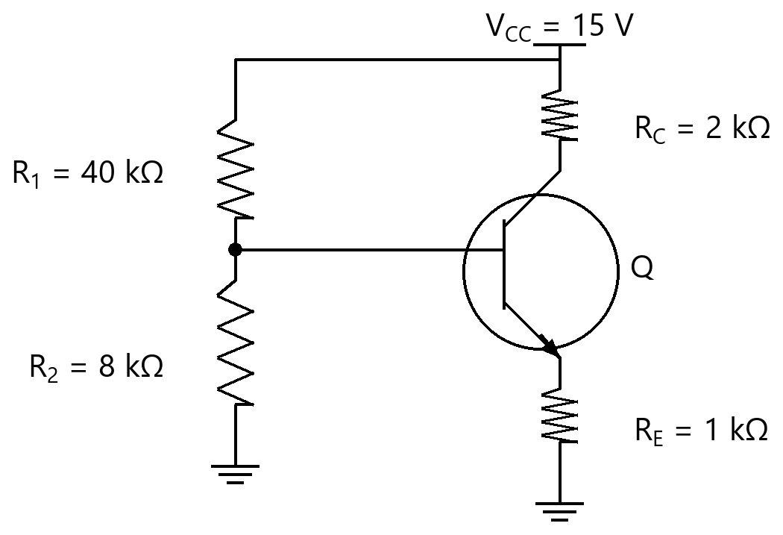
Option | $\scriptstyle I_C$ ≈ 2.5 mA, $\scriptstyle V_{CE}$ ≈ 9.6 V  $\scriptstyle I_C$ ≈ 2.5 mA, $\scriptstyle V_{CE}$ ≈ 9.6 V
Option | $\scriptstyle I_C$ ≈ 1.8 mA, $\scriptstyle V_{CE}$ ≈ 11.4 V  $\scriptstyle I_C$ ≈ 1.8 mA, $\scriptstyle V_{CE}$ ≈ 11.4 V
Option | $\scriptstyle I_C$ ≈ 1.8 mA, $\scriptstyle V_{CE}$ ≈ 9.6 V  $\scriptstyle I_C$ ≈ 1.8 mA, $\scriptstyle V_{CE}$ ≈ 9.6 V
Option | $\scriptstyle I_C$ ≈ 2.7 mA, $\scriptstyle V_{CE}$ ≈ 9.6 V  $\scriptstyle I_C$ ≈ 2.7 mA, $\scriptstyle V_{CE}$ ≈ 9.6 V
Correct | 3
Explanation | 1. Core Concept & Formula  Thevenin the base divider: $\scriptstyle V_B$ = $\scriptstyle V_{CC}$·$\scriptstyle R_2$/($\scriptstyle R_1$+$\scriptstyle R_2$); $\scriptstyle V_E$ = $\scriptstyle V_B$ − 0.7; $\scriptstyle I_C$ ≈ $\scriptstyle I_E$ = $\scriptstyle V_E$/$\scriptstyle R_E$; $\scriptstyle V_{CE}$ = $\scriptstyle V_{CC}$ − $\scriptstyle I_C$($\scriptstyle R_C$+$\scriptstyle R_E$).  $\scriptstyle V_B = V_{CC}\cdot R_2/(R_1+R_2)$  $\scriptstyle I_C$ ≈ ($\scriptstyle V_B$ − 0.7)/$\scriptstyle R_E$  $\scriptstyle V_{CE}$ = $\scriptstyle V_{CC}$ − $\scriptstyle I_C$($\scriptstyle R_C$+$\scriptstyle R_E$)  2. Calculation Steps  $\scriptstyle V_B = 15×8/(40+8) = 2.5 V$  $\scriptstyle I_C ≈ (2.5 − 0.7)/1 = 1.8 \text{mA}$  $\scriptstyle V_{CE} = 15 − 1.8×(2+1) = 9.6 V$  Final Answer: $\scriptstyle I_C$ ≈ 1.8 mA, $\scriptstyle V_{CE}$ ≈ 9.6 V
Subject | Analog Electronics
Topic | BJT (DC Analysis and Biasing Circuits of BJT)
Correct Marks | 3
Incorrect Marks | 1
Hint | -
Video Solution | -
PYQ
OTS ID | AJEEEANE2130513

Question | 514
Type | MCQ
Body | For the voltage-divider biased npn stage shown ($\scriptstyle V_{CC}$ = 12 V, $\scriptstyle R_1$ = 47 kΩ, $\scriptstyle R_2$ = 12 kΩ, $\scriptstyle R_C$ = 1.5 kΩ, $\scriptstyle R_E$ = 0.8 kΩ, $\scriptstyle V_{BE}$ = 0.7 V, large β), the Q-point ($\scriptstyle I_C$, $\scriptstyle V_{CE}$) is approximately:  दिखाए गए वोल्टेज-विभाजक बायस npn चरण के लिए ($\scriptstyle V_{CC}$ = 12 V, $\scriptstyle R_1$ = 47 kΩ, $\scriptstyle R_2$ = 12 kΩ, $\scriptstyle R_C$ = 1.5 kΩ, $\scriptstyle R_E$ = 0.8 kΩ, $\scriptstyle V_{BE}$ = 0.7 V, बड़ा β), Q-बिंदु ($\scriptstyle I_C$, $\scriptstyle V_{CE}$) लगभग है:  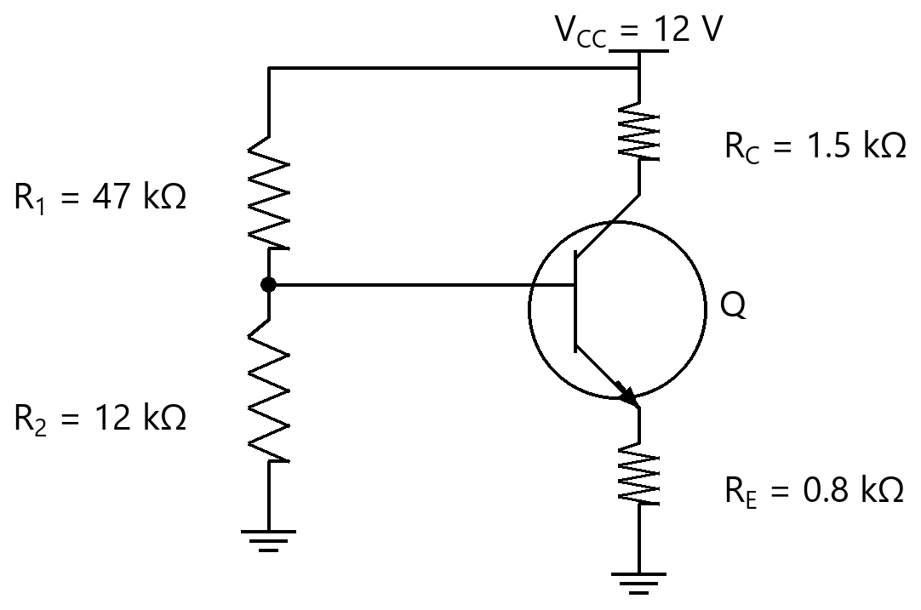
Option | $\scriptstyle I_C$ ≈ 3.05 mA, $\scriptstyle V_{CE}$ ≈ 6.99 V  $\scriptstyle I_C$ ≈ 3.05 mA, $\scriptstyle V_{CE}$ ≈ 6.99 V
Option | $\scriptstyle I_C$ ≈ 2.18 mA, $\scriptstyle V_{CE}$ ≈ 8.73 V  $\scriptstyle I_C$ ≈ 2.18 mA, $\scriptstyle V_{CE}$ ≈ 8.73 V
Option | $\scriptstyle I_C$ ≈ 3.26 mA, $\scriptstyle V_{CE}$ ≈ 6.99 V  $\scriptstyle I_C$ ≈ 3.26 mA, $\scriptstyle V_{CE}$ ≈ 6.99 V
Option | $\scriptstyle I_C$ ≈ 2.18 mA, $\scriptstyle V_{CE}$ ≈ 6.99 V  $\scriptstyle I_C$ ≈ 2.18 mA, $\scriptstyle V_{CE}$ ≈ 6.99 V
Correct | 4
Explanation | 1. Core Concept & Formula  Thevenin the base divider: $\scriptstyle V_B$ = $\scriptstyle V_{CC}$·$\scriptstyle R_2$/($\scriptstyle R_1$+$\scriptstyle R_2$); $\scriptstyle V_E$ = $\scriptstyle V_B$ − 0.7; $\scriptstyle I_C$ ≈ $\scriptstyle I_E$ = $\scriptstyle V_E$/$\scriptstyle R_E$; $\scriptstyle V_{CE}$ = $\scriptstyle V_{CC}$ − $\scriptstyle I_C$($\scriptstyle R_C$+$\scriptstyle R_E$).  $\scriptstyle V_B = V_{CC}\cdot R_2/(R_1+R_2)$  $\scriptstyle I_C$ ≈ ($\scriptstyle V_B$ − 0.7)/$\scriptstyle R_E$  $\scriptstyle V_{CE}$ = $\scriptstyle V_{CC}$ − $\scriptstyle I_C$($\scriptstyle R_C$+$\scriptstyle R_E$)  2. Calculation Steps  $\scriptstyle V_B = 12×12/(47+12) = 2.44 V$  $\scriptstyle I_C ≈ (2.44 − 0.7)/0.8 = 2.18 \text{mA}$  $\scriptstyle V_{CE} = 12 − 2.18×(1.5+0.8) = 6.99 V$  Final Answer: $\scriptstyle I_C$ ≈ 2.18 mA, $\scriptstyle V_{CE}$ ≈ 6.99 V
Subject | Analog Electronics
Topic | BJT (DC Analysis and Biasing Circuits of BJT)
Correct Marks | 3
Incorrect Marks | 1
Hint | -
Video Solution | -
PYQ
OTS ID | AJEEEANE2130514

Question | 515
Type | MCQ
Body | For the voltage-divider biased npn stage shown ($\scriptstyle V_{CC}$ = 10 V, $\scriptstyle R_1$ = 20 kΩ, $\scriptstyle R_2$ = 10 kΩ, $\scriptstyle R_C$ = 1 kΩ, $\scriptstyle R_E$ = 1 kΩ, $\scriptstyle V_{BE}$ = 0.7 V, large β), the Q-point ($\scriptstyle I_C$, $\scriptstyle V_{CE}$) is approximately:  दिखाए गए वोल्टेज-विभाजक बायस npn चरण के लिए ($\scriptstyle V_{CC}$ = 10 V, $\scriptstyle R_1$ = 20 kΩ, $\scriptstyle R_2$ = 10 kΩ, $\scriptstyle R_C$ = 1 kΩ, $\scriptstyle R_E$ = 1 kΩ, $\scriptstyle V_{BE}$ = 0.7 V, बड़ा β), Q-बिंदु ($\scriptstyle I_C$, $\scriptstyle V_{CE}$) लगभग है:  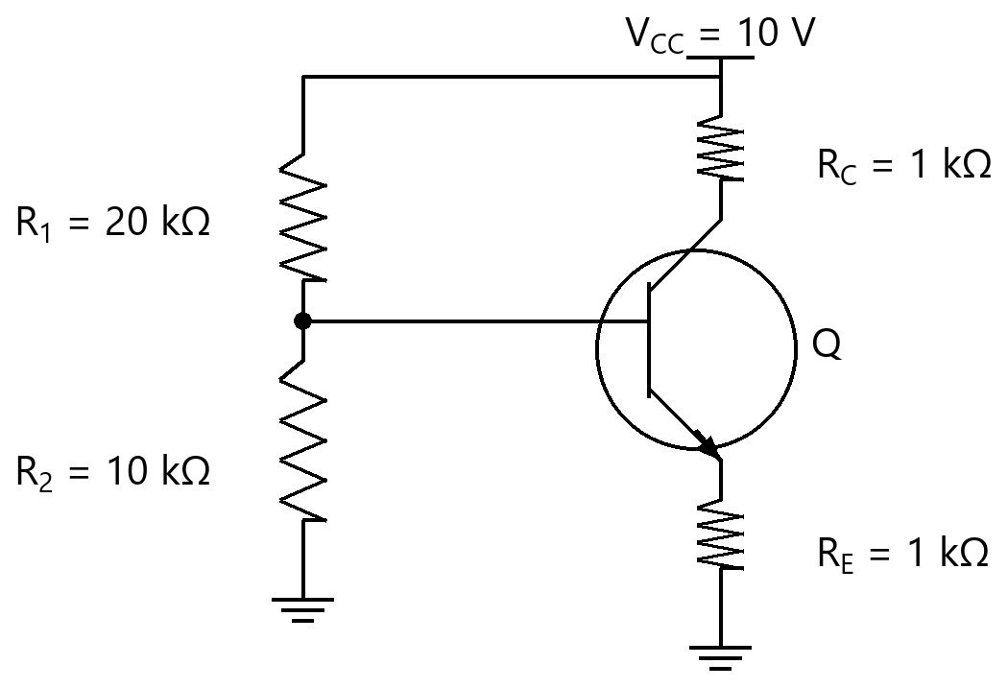
Option | $\scriptstyle I_C$ ≈ 2.63 mA, $\scriptstyle V_{CE}$ ≈ 4.74 V  $\scriptstyle I_C$ ≈ 2.63 mA, $\scriptstyle V_{CE}$ ≈ 4.74 V
Option | $\scriptstyle I_C$ ≈ 3.33 mA, $\scriptstyle V_{CE}$ ≈ 4.74 V  $\scriptstyle I_C$ ≈ 3.33 mA, $\scriptstyle V_{CE}$ ≈ 4.74 V
Option | $\scriptstyle I_C$ ≈ 2.63 mA, $\scriptstyle V_{CE}$ ≈ 7.37 V  $\scriptstyle I_C$ ≈ 2.63 mA, $\scriptstyle V_{CE}$ ≈ 7.37 V
Option | $\scriptstyle I_C$ ≈ 3.95 mA, $\scriptstyle V_{CE}$ ≈ 4.74 V  $\scriptstyle I_C$ ≈ 3.95 mA, $\scriptstyle V_{CE}$ ≈ 4.74 V
Correct | 1
Explanation | 1. Core Concept & Formula  Thevenin the base divider: $\scriptstyle V_B$ = $\scriptstyle V_{CC}$·$\scriptstyle R_2$/($\scriptstyle R_1$+$\scriptstyle R_2$); $\scriptstyle V_E$ = $\scriptstyle V_B$ − 0.7; $\scriptstyle I_C$ ≈ $\scriptstyle I_E$ = $\scriptstyle V_E$/$\scriptstyle R_E$; $\scriptstyle V_{CE}$ = $\scriptstyle V_{CC}$ − $\scriptstyle I_C$($\scriptstyle R_C$+$\scriptstyle R_E$).  $\scriptstyle V_B = V_{CC}\cdot R_2/(R_1+R_2)$  $\scriptstyle I_C$ ≈ ($\scriptstyle V_B$ − 0.7)/$\scriptstyle R_E$  $\scriptstyle V_{CE}$ = $\scriptstyle V_{CC}$ − $\scriptstyle I_C$($\scriptstyle R_C$+$\scriptstyle R_E$)  2. Calculation Steps  $\scriptstyle V_B = 10×10/(20+10) = 3.33 V$  $\scriptstyle I_C ≈ (3.33 − 0.7)/1 = 2.63 \text{mA}$  $\scriptstyle V_{CE} = 10 − 2.63×(1+1) = 4.74 V$  Final Answer: $\scriptstyle I_C$ ≈ 2.63 mA, $\scriptstyle V_{CE}$ ≈ 4.74 V
Subject | Analog Electronics
Topic | BJT (DC Analysis and Biasing Circuits of BJT)
Correct Marks | 3
Incorrect Marks | 1
Hint | -
Video Solution | -
PYQ
OTS ID | AJEEEANE2130515

Question | 516
Type | MCQ
Body | For the ideal inverting op-amp amplifier shown, $\scriptstyle R_{in}$ = 10 kΩ, $\scriptstyle R_f$ = 100 kΩ and $\scriptstyle V_{in}$ = 1 V. The output voltage $\scriptstyle V_o$ is:  दिखाए गए आदर्श व्युत्क्रमी (inverting) op-amp प्रवर्धक के लिए, $\scriptstyle R_{in}$ = 10 kΩ, $\scriptstyle R_f$ = 100 kΩ तथा $\scriptstyle V_{in}$ = 1 V। निर्गत वोल्टता $\scriptstyle V_o$ है:  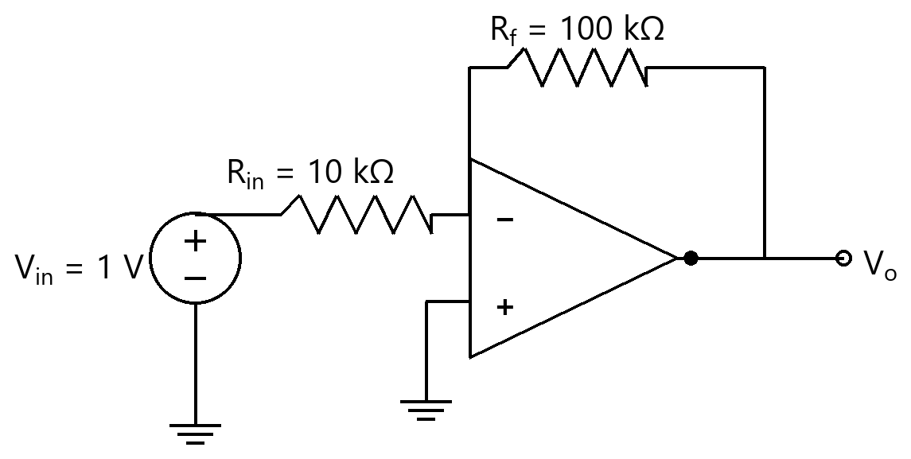
Option | -0.1 V  -0.1 V
Option | -10.0 V  -10.0 V
Option | 11.0 V  11.0 V
Option | 10.0 V  10.0 V
Correct | 2
Explanation | 1. Core Concept & Formula  An ideal inverting amplifier has a virtual ground at the inverting input; the closed-loop gain is −$\scriptstyle R_f$/$\scriptstyle R_{in}$.  $\scriptstyle V_o$ = −($\scriptstyle R_f$/$\scriptstyle R_{in}$)·$\scriptstyle V_{in}$  2. Calculation Steps  $\scriptstyle V_o = −(100/10)×1 = -10.0 V$  Final Answer: -10.0 V
Subject | Analog Electronics
Topic | OP-AMP and its Applications (Op-amp)
Correct Marks | 3
Incorrect Marks | 1
Hint | -
Video Solution | -
PYQ
OTS ID | AJEEEANE6120516

Question | 517
Type | MCQ
Body | For the ideal inverting op-amp amplifier shown, $\scriptstyle R_{in}$ = 10 kΩ, $\scriptstyle R_f$ = 50 kΩ and $\scriptstyle V_{in}$ = 2 V. The output voltage $\scriptstyle V_o$ is:  दिखाए गए आदर्श व्युत्क्रमी (inverting) op-amp प्रवर्धक के लिए, $\scriptstyle R_{in}$ = 10 kΩ, $\scriptstyle R_f$ = 50 kΩ तथा $\scriptstyle V_{in}$ = 2 V। निर्गत वोल्टता $\scriptstyle V_o$ है:  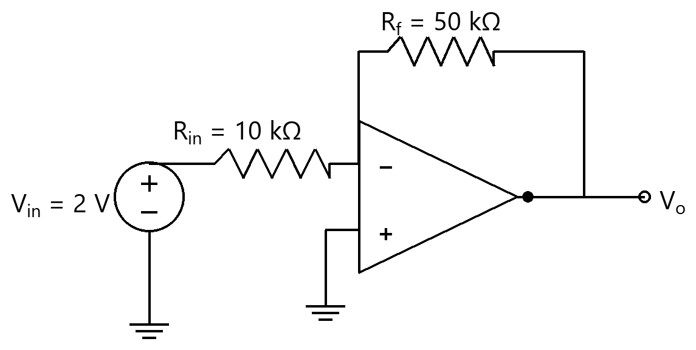
Option | -0.4 V  -0.4 V
Option | 12.0 V  12.0 V
Option | -10.0 V  -10.0 V
Option | 10.0 V  10.0 V
Correct | 3
Explanation | 1. Core Concept & Formula  An ideal inverting amplifier has a virtual ground at the inverting input; the closed-loop gain is −$\scriptstyle R_f$/$\scriptstyle R_{in}$.  $\scriptstyle V_o$ = −($\scriptstyle R_f$/$\scriptstyle R_{in}$)·$\scriptstyle V_{in}$  2. Calculation Steps  $\scriptstyle V_o = −(50/10)×2 = -10.0 V$  Final Answer: -10.0 V
Subject | Analog Electronics
Topic | OP-AMP and its Applications (Op-amp)
Correct Marks | 3
Incorrect Marks | 1
Hint | -
Video Solution | -
PYQ
OTS ID | AJEEEANE6120517

Question | 518
Type | MCQ
Body | For the ideal inverting op-amp amplifier shown, $\scriptstyle R_{in}$ = 5 kΩ, $\scriptstyle R_f$ = 20 kΩ and $\scriptstyle V_{in}$ = 0.5 V. The output voltage $\scriptstyle V_o$ is:  दिखाए गए आदर्श व्युत्क्रमी (inverting) op-amp प्रवर्धक के लिए, $\scriptstyle R_{in}$ = 5 kΩ, $\scriptstyle R_f$ = 20 kΩ तथा $\scriptstyle V_{in}$ = 0.5 V। निर्गत वोल्टता $\scriptstyle V_o$ है:  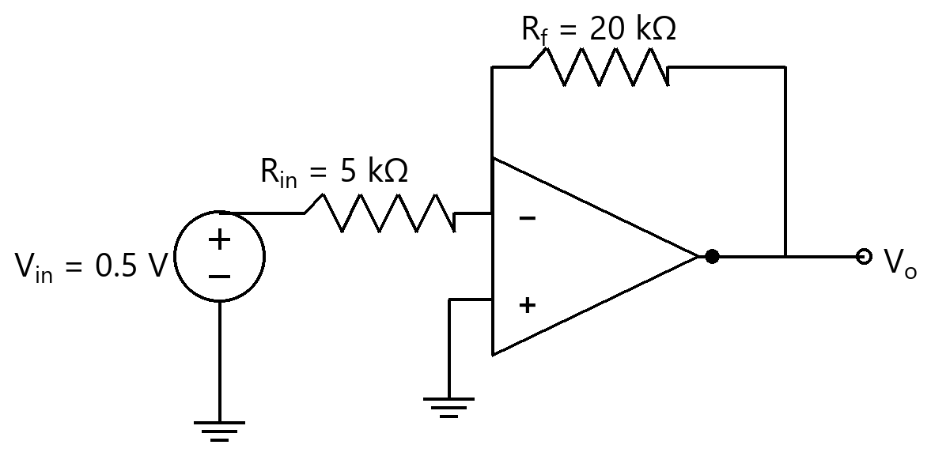
Option | -0.12 V  -0.12 V
Option | 2.5 V  2.5 V
Option | 2.0 V  2.0 V
Option | -2.0 V  -2.0 V
Correct | 4
Explanation | 1. Core Concept & Formula  An ideal inverting amplifier has a virtual ground at the inverting input; the closed-loop gain is −$\scriptstyle R_f$/$\scriptstyle R_{in}$.  $\scriptstyle V_o$ = −($\scriptstyle R_f$/$\scriptstyle R_{in}$)·$\scriptstyle V_{in}$  2. Calculation Steps  $\scriptstyle V_o = −(20/5)×0.5 = -2.0 V$  Final Answer: -2.0 V
Subject | Analog Electronics
Topic | OP-AMP and its Applications (Op-amp)
Correct Marks | 3
Incorrect Marks | 1
Hint | -
Video Solution | -
PYQ
OTS ID | AJEEEANE6120518

Question | 519
Type | MCQ
Body | For the ideal inverting op-amp amplifier shown, $\scriptstyle R_{in}$ = 2 kΩ, $\scriptstyle R_f$ = 22 kΩ and $\scriptstyle V_{in}$ = 1 V. The output voltage $\scriptstyle V_o$ is:  दिखाए गए आदर्श व्युत्क्रमी (inverting) op-amp प्रवर्धक के लिए, $\scriptstyle R_{in}$ = 2 kΩ, $\scriptstyle R_f$ = 22 kΩ तथा $\scriptstyle V_{in}$ = 1 V। निर्गत वोल्टता $\scriptstyle V_o$ है:  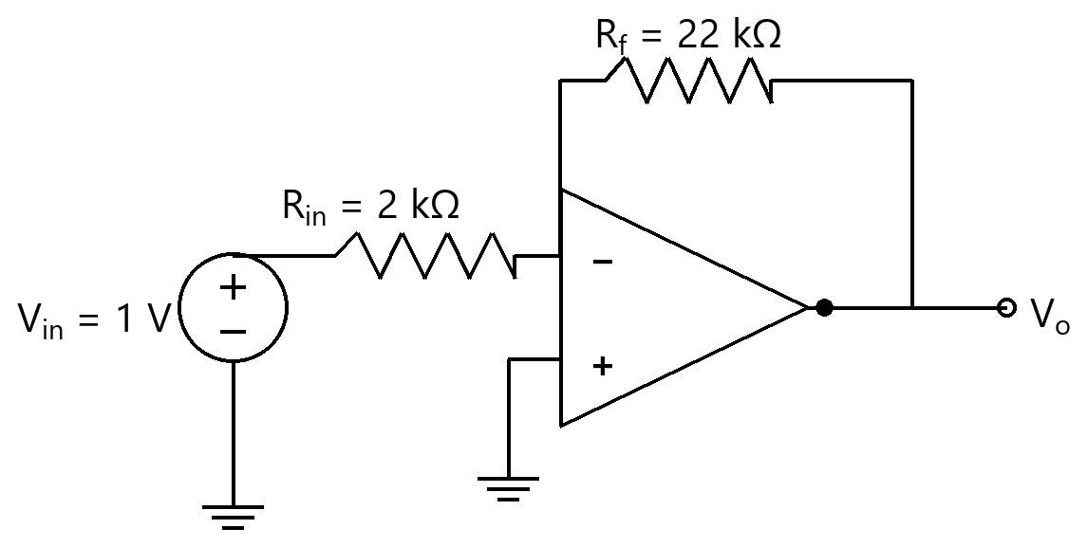
Option | -11.0 V  -11.0 V
Option | -0.09 V  -0.09 V
Option | 12.0 V  12.0 V
Option | 11.0 V  11.0 V
Correct | 1
Explanation | 1. Core Concept & Formula  An ideal inverting amplifier has a virtual ground at the inverting input; the closed-loop gain is −$\scriptstyle R_f$/$\scriptstyle R_{in}$.  $\scriptstyle V_o$ = −($\scriptstyle R_f$/$\scriptstyle R_{in}$)·$\scriptstyle V_{in}$  2. Calculation Steps  $\scriptstyle V_o = −(22/2)×1 = -11.0 V$  Final Answer: -11.0 V
Subject | Analog Electronics
Topic | OP-AMP and its Applications (Op-amp)
Correct Marks | 3
Incorrect Marks | 1
Hint | -
Video Solution | -
PYQ
OTS ID | AJEEEANE6120519

Question | 520
Type | MCQ
Body | For the ideal inverting op-amp amplifier shown, $\scriptstyle R_{in}$ = 4 kΩ, $\scriptstyle R_f$ = 12 kΩ and $\scriptstyle V_{in}$ = 2 V. The output voltage $\scriptstyle V_o$ is:  दिखाए गए आदर्श व्युत्क्रमी (inverting) op-amp प्रवर्धक के लिए, $\scriptstyle R_{in}$ = 4 kΩ, $\scriptstyle R_f$ = 12 kΩ तथा $\scriptstyle V_{in}$ = 2 V। निर्गत वोल्टता $\scriptstyle V_o$ है:  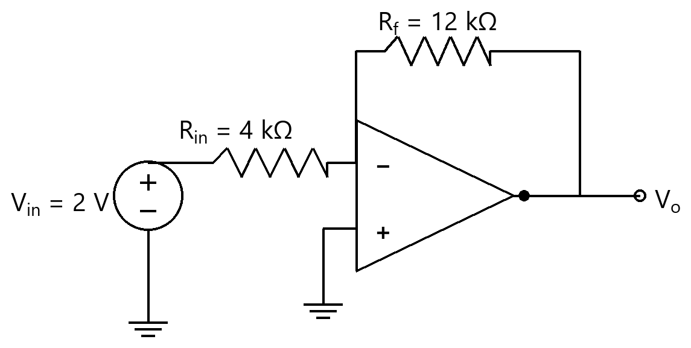
Option | -0.67 V  -0.67 V
Option | -6.0 V  -6.0 V
Option | 8.0 V  8.0 V
Option | 6.0 V  6.0 V
Correct | 2
Explanation | 1. Core Concept & Formula  An ideal inverting amplifier has a virtual ground at the inverting input; the closed-loop gain is −$\scriptstyle R_f$/$\scriptstyle R_{in}$.  $\scriptstyle V_o$ = −($\scriptstyle R_f$/$\scriptstyle R_{in}$)·$\scriptstyle V_{in}$  2. Calculation Steps  $\scriptstyle V_o = −(12/4)×2 = -6.0 V$  Final Answer: -6.0 V
Subject | Analog Electronics
Topic | OP-AMP and its Applications (Op-amp)
Correct Marks | 3
Incorrect Marks | 1
Hint | -
Video Solution | -
PYQ
OTS ID | AJEEEANE6120520

Question | 521
Type | MCQ
Body | For the ideal inverting op-amp amplifier shown, $\scriptstyle R_{in}$ = 1 kΩ, $\scriptstyle R_f$ = 100 kΩ and $\scriptstyle V_{in}$ = 0.2 V. The output voltage $\scriptstyle V_o$ is:  दिखाए गए आदर्श व्युत्क्रमी (inverting) op-amp प्रवर्धक के लिए, $\scriptstyle R_{in}$ = 1 kΩ, $\scriptstyle R_f$ = 100 kΩ तथा $\scriptstyle V_{in}$ = 0.2 V। निर्गत वोल्टता $\scriptstyle V_o$ है:  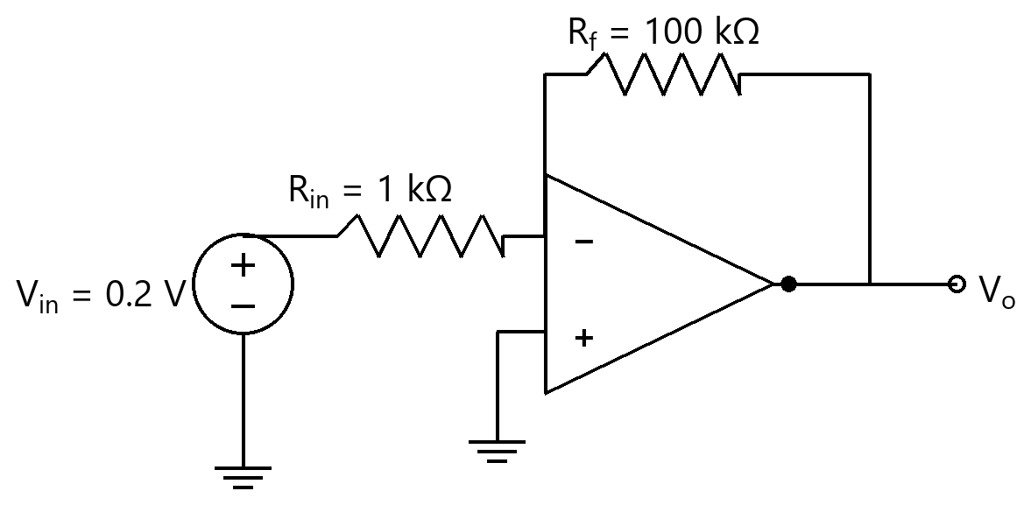
Option | -0.0 V  -0.0 V
Option | 20.2 V  20.2 V
Option | -20.0 V  -20.0 V
Option | 20.0 V  20.0 V
Correct | 3
Explanation | 1. Core Concept & Formula  An ideal inverting amplifier has a virtual ground at the inverting input; the closed-loop gain is −$\scriptstyle R_f$/$\scriptstyle R_{in}$.  $\scriptstyle V_o$ = −($\scriptstyle R_f$/$\scriptstyle R_{in}$)·$\scriptstyle V_{in}$  2. Calculation Steps  $\scriptstyle V_o = −(100/1)×0.2 = -20.0 V$  Final Answer: -20.0 V
Subject | Analog Electronics
Topic | OP-AMP and its Applications (Op-amp)
Correct Marks | 3
Incorrect Marks | 1
Hint | -
Video Solution | -
PYQ
OTS ID | AJEEEANE6120521

Question | 522
Type | MCQ
Body | For the ideal inverting op-amp amplifier shown, $\scriptstyle R_{in}$ = 10 kΩ, $\scriptstyle R_f$ = 20 kΩ and $\scriptstyle V_{in}$ = 1.5 V. The output voltage $\scriptstyle V_o$ is:  दिखाए गए आदर्श व्युत्क्रमी (inverting) op-amp प्रवर्धक के लिए, $\scriptstyle R_{in}$ = 10 kΩ, $\scriptstyle R_f$ = 20 kΩ तथा $\scriptstyle V_{in}$ = 1.5 V। निर्गत वोल्टता $\scriptstyle V_o$ है:  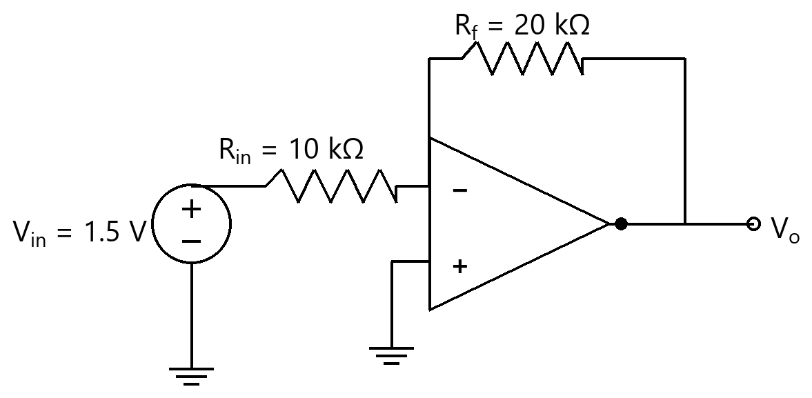
Option | -0.75 V  -0.75 V
Option | 4.5 V  4.5 V
Option | 3.0 V  3.0 V
Option | -3.0 V  -3.0 V
Correct | 4
Explanation | 1. Core Concept & Formula  An ideal inverting amplifier has a virtual ground at the inverting input; the closed-loop gain is −$\scriptstyle R_f$/$\scriptstyle R_{in}$.  $\scriptstyle V_o$ = −($\scriptstyle R_f$/$\scriptstyle R_{in}$)·$\scriptstyle V_{in}$  2. Calculation Steps  $\scriptstyle V_o = −(20/10)×1.5 = -3.0 V$  Final Answer: -3.0 V
Subject | Analog Electronics
Topic | OP-AMP and its Applications (Op-amp)
Correct Marks | 3
Incorrect Marks | 1
Hint | -
Video Solution | -
PYQ
OTS ID | AJEEEANE6120522

Question | 523
Type | MCQ
Body | For the ideal inverting op-amp amplifier shown, $\scriptstyle R_{in}$ = 10 kΩ, $\scriptstyle R_f$ = 30 kΩ and $\scriptstyle V_{in}$ = 3 V. The output voltage $\scriptstyle V_o$ is:  दिखाए गए आदर्श व्युत्क्रमी (inverting) op-amp प्रवर्धक के लिए, $\scriptstyle R_{in}$ = 10 kΩ, $\scriptstyle R_f$ = 30 kΩ तथा $\scriptstyle V_{in}$ = 3 V। निर्गत वोल्टता $\scriptstyle V_o$ है:  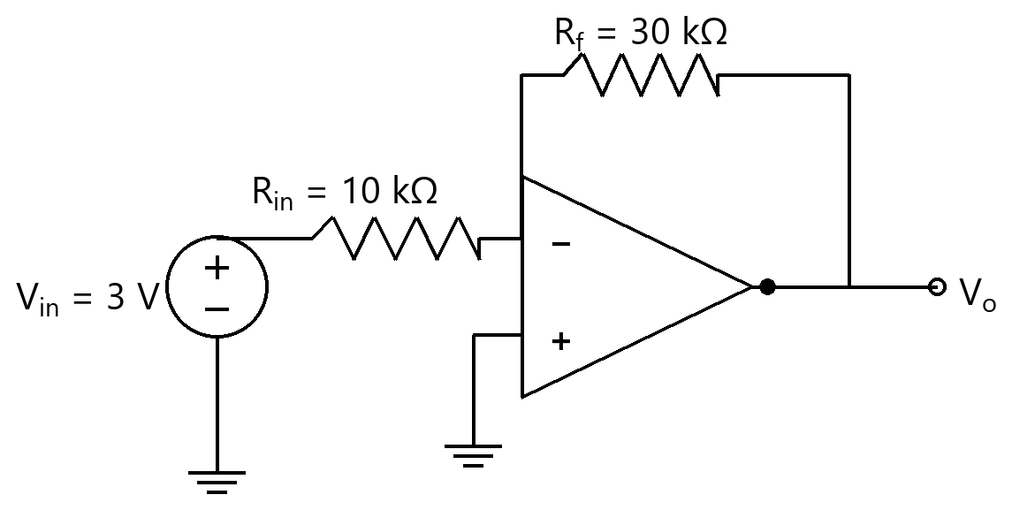
Option | -9.0 V  -9.0 V
Option | -1.0 V  -1.0 V
Option | 12.0 V  12.0 V
Option | 9.0 V  9.0 V
Correct | 1
Explanation | 1. Core Concept & Formula  An ideal inverting amplifier has a virtual ground at the inverting input; the closed-loop gain is −$\scriptstyle R_f$/$\scriptstyle R_{in}$.  $\scriptstyle V_o$ = −($\scriptstyle R_f$/$\scriptstyle R_{in}$)·$\scriptstyle V_{in}$  2. Calculation Steps  $\scriptstyle V_o = −(30/10)×3 = -9.0 V$  Final Answer: -9.0 V
Subject | Analog Electronics
Topic | OP-AMP and its Applications (Op-amp)
Correct Marks | 3
Incorrect Marks | 1
Hint | -
Video Solution | -
PYQ
OTS ID | AJEEEANE6120523

Question | 524
Type | MCQ
Body | For the ideal non-inverting op-amp amplifier shown, $\scriptstyle R_1$ = 10 kΩ (to ground), $\scriptstyle R_f$ = 10 kΩ (feedback) and $\scriptstyle V_{in}$ = 1 V at the (+) input. The output voltage $\scriptstyle V_o$ is:  दिखाए गए आदर्श अव्युत्क्रमी (non-inverting) op-amp प्रवर्धक के लिए, $\scriptstyle R_1$ = 10 kΩ (भू-संपर्क तक), $\scriptstyle R_f$ = 10 kΩ (पुनर्भरण) तथा (+) निवेश पर $\scriptstyle V_{in}$ = 1 V। निर्गत वोल्टता $\scriptstyle V_o$ है:  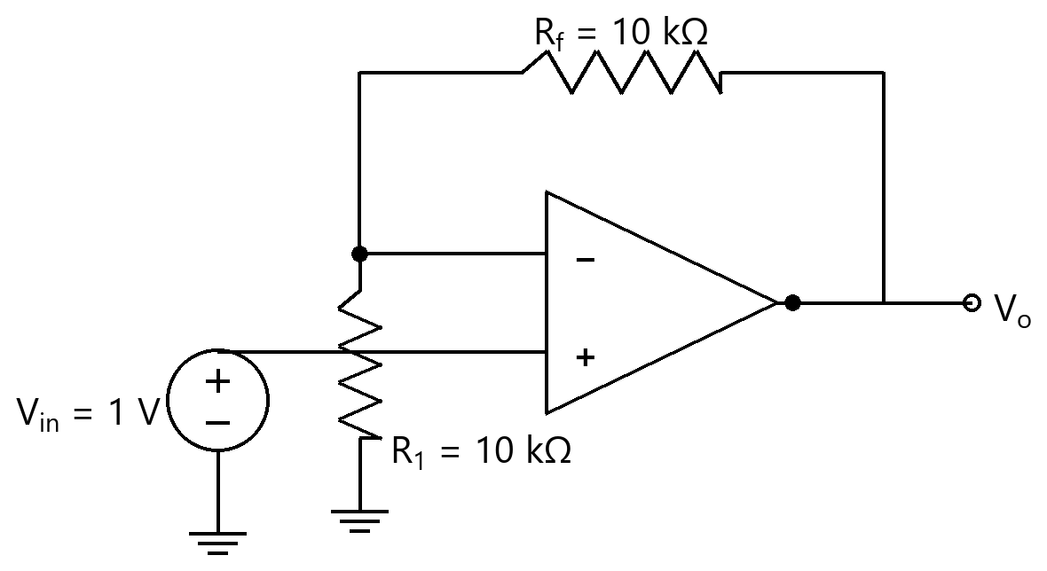
Option | -1.0 V  -1.0 V
Option | 2.0 V  2.0 V
Option | 1.0 V  1.0 V
Option | 1 V  1 V
Correct | 2
Explanation | 1. Core Concept & Formula  The non-inverting amplifier's closed-loop gain is 1 + $\scriptstyle R_f$/$\scriptstyle R_1$ (in phase with the input).  $\scriptstyle V_o = (1 + R_f/R_1)\cdot V_{in}$  2. Calculation Steps  $\scriptstyle V_o = (1 + 10/10)×1 = 2.0 V$  Final Answer: 2.0 V
Subject | Analog Electronics
Topic | OP-AMP and its Applications (Op-amp)
Correct Marks | 3
Incorrect Marks | 1
Hint | -
Video Solution | -
PYQ
OTS ID | AJEEEANE6120524

Question | 525
Type | MCQ
Body | For the ideal non-inverting op-amp amplifier shown, $\scriptstyle R_1$ = 10 kΩ (to ground), $\scriptstyle R_f$ = 20 kΩ (feedback) and $\scriptstyle V_{in}$ = 2 V at the (+) input. The output voltage $\scriptstyle V_o$ is:  दिखाए गए आदर्श अव्युत्क्रमी (non-inverting) op-amp प्रवर्धक के लिए, $\scriptstyle R_1$ = 10 kΩ (भू-संपर्क तक), $\scriptstyle R_f$ = 20 kΩ (पुनर्भरण) तथा (+) निवेश पर $\scriptstyle V_{in}$ = 2 V। निर्गत वोल्टता $\scriptstyle V_o$ है:  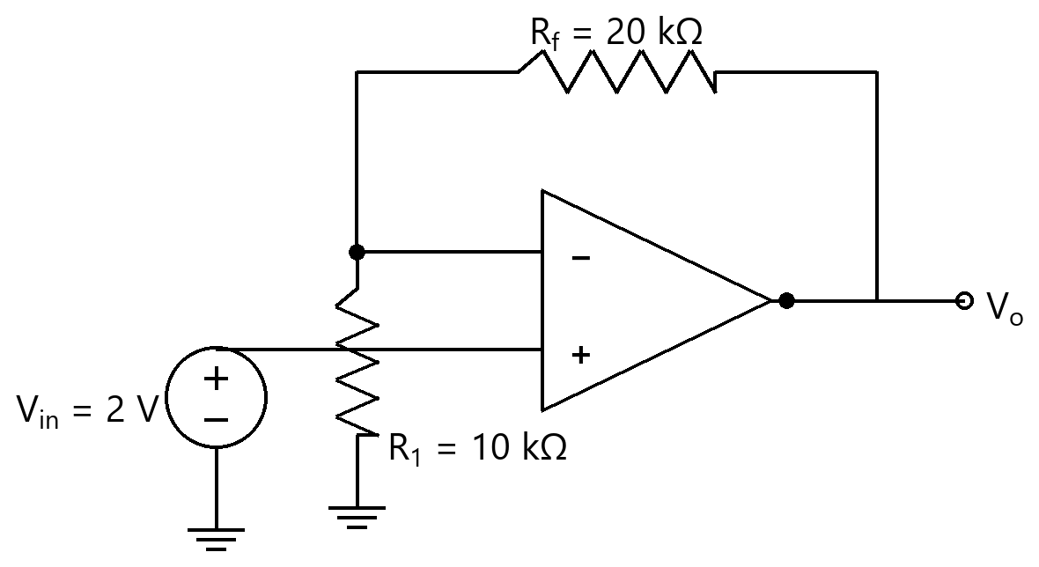
Option | -4.0 V  -4.0 V
Option | 4.0 V  4.0 V
Option | 6.0 V  6.0 V
Option | 2 V  2 V
Correct | 3
Explanation | 1. Core Concept & Formula  The non-inverting amplifier's closed-loop gain is 1 + $\scriptstyle R_f$/$\scriptstyle R_1$ (in phase with the input).  $\scriptstyle V_o = (1 + R_f/R_1)\cdot V_{in}$  2. Calculation Steps  $\scriptstyle V_o = (1 + 20/10)×2 = 6.0 V$  Final Answer: 6.0 V
Subject | Analog Electronics
Topic | OP-AMP and its Applications (Op-amp)
Correct Marks | 3
Incorrect Marks | 1
Hint | -
Video Solution | -
PYQ
OTS ID | AJEEEANE6120525

Question | 526
Type | MCQ
Body | For the ideal non-inverting op-amp amplifier shown, $\scriptstyle R_1$ = 10 kΩ (to ground), $\scriptstyle R_f$ = 30 kΩ (feedback) and $\scriptstyle V_{in}$ = 1 V at the (+) input. The output voltage $\scriptstyle V_o$ is:  दिखाए गए आदर्श अव्युत्क्रमी (non-inverting) op-amp प्रवर्धक के लिए, $\scriptstyle R_1$ = 10 kΩ (भू-संपर्क तक), $\scriptstyle R_f$ = 30 kΩ (पुनर्भरण) तथा (+) निवेश पर $\scriptstyle V_{in}$ = 1 V। निर्गत वोल्टता $\scriptstyle V_o$ है:  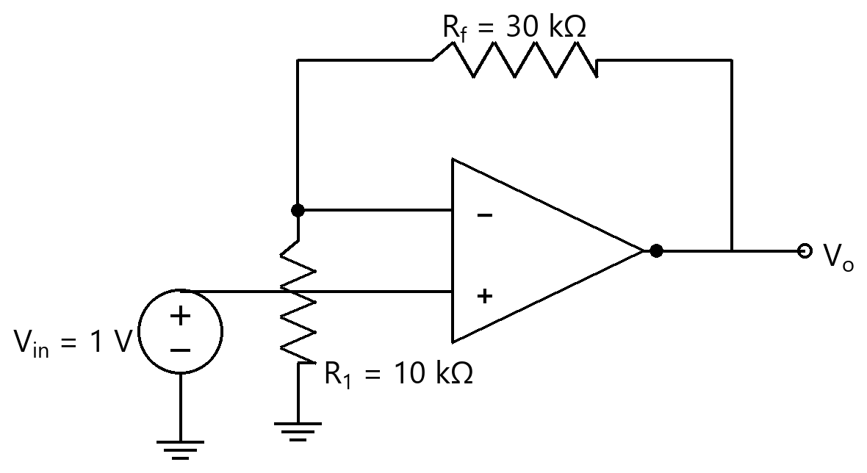
Option | -3.0 V  -3.0 V
Option | 3.0 V  3.0 V
Option | 1 V  1 V
Option | 4.0 V  4.0 V
Correct | 4
Explanation | 1. Core Concept & Formula  The non-inverting amplifier's closed-loop gain is 1 + $\scriptstyle R_f$/$\scriptstyle R_1$ (in phase with the input).  $\scriptstyle V_o = (1 + R_f/R_1)\cdot V_{in}$  2. Calculation Steps  $\scriptstyle V_o = (1 + 30/10)×1 = 4.0 V$  Final Answer: 4.0 V
Subject | Analog Electronics
Topic | OP-AMP and its Applications (Op-amp)
Correct Marks | 3
Incorrect Marks | 1
Hint | -
Video Solution | -
PYQ
OTS ID | AJEEEANE6120526

Question | 527
Type | MCQ
Body | For the ideal non-inverting op-amp amplifier shown, $\scriptstyle R_1$ = 2 kΩ (to ground), $\scriptstyle R_f$ = 8 kΩ (feedback) and $\scriptstyle V_{in}$ = 0.5 V at the (+) input. The output voltage $\scriptstyle V_o$ is:  दिखाए गए आदर्श अव्युत्क्रमी (non-inverting) op-amp प्रवर्धक के लिए, $\scriptstyle R_1$ = 2 kΩ (भू-संपर्क तक), $\scriptstyle R_f$ = 8 kΩ (पुनर्भरण) तथा (+) निवेश पर $\scriptstyle V_{in}$ = 0.5 V। निर्गत वोल्टता $\scriptstyle V_o$ है:  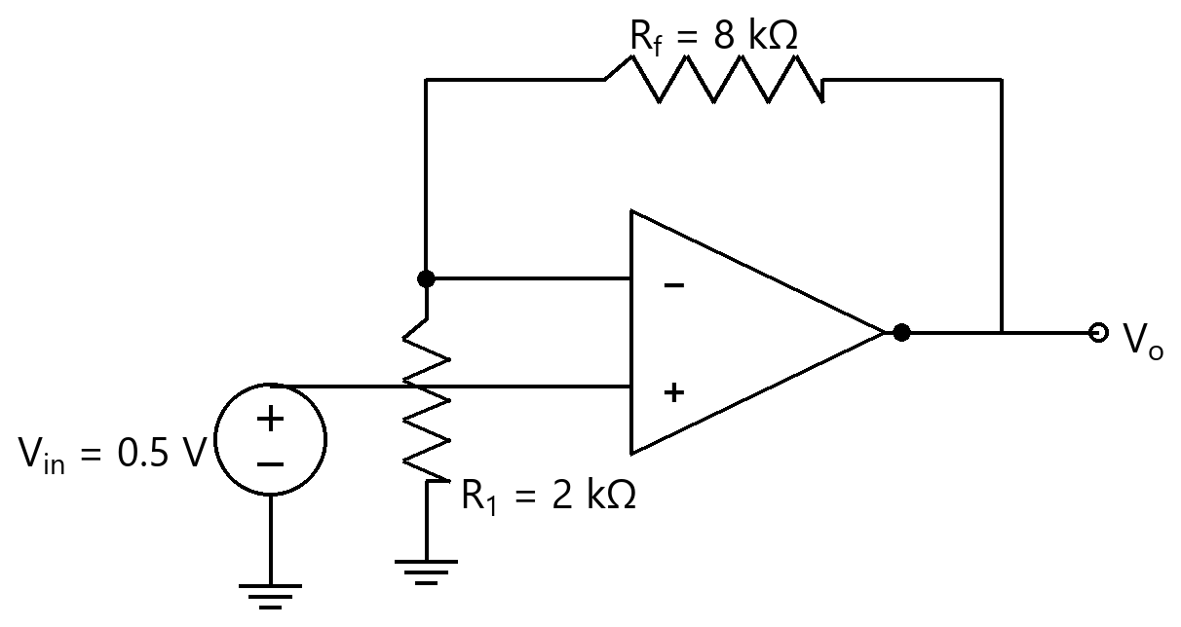
Option | 2.5 V  2.5 V
Option | -2.0 V  -2.0 V
Option | 2.0 V  2.0 V
Option | 0.5 V  0.5 V
Correct | 1
Explanation | 1. Core Concept & Formula  The non-inverting amplifier's closed-loop gain is 1 + $\scriptstyle R_f$/$\scriptstyle R_1$ (in phase with the input).  $\scriptstyle V_o = (1 + R_f/R_1)\cdot V_{in}$  2. Calculation Steps  $\scriptstyle V_o = (1 + 8/2)×0.5 = 2.5 V$  Final Answer: 2.5 V
Subject | Analog Electronics
Topic | OP-AMP and its Applications (Op-amp)
Correct Marks | 3
Incorrect Marks | 1
Hint | -
Video Solution | -
PYQ
OTS ID | AJEEEANE6120527

Question | 528
Type | MCQ
Body | For the ideal non-inverting op-amp amplifier shown, $\scriptstyle R_1$ = 5 kΩ (to ground), $\scriptstyle R_f$ = 15 kΩ (feedback) and $\scriptstyle V_{in}$ = 2 V at the (+) input. The output voltage $\scriptstyle V_o$ is:  दिखाए गए आदर्श अव्युत्क्रमी (non-inverting) op-amp प्रवर्धक के लिए, $\scriptstyle R_1$ = 5 kΩ (भू-संपर्क तक), $\scriptstyle R_f$ = 15 kΩ (पुनर्भरण) तथा (+) निवेश पर $\scriptstyle V_{in}$ = 2 V। निर्गत वोल्टता $\scriptstyle V_o$ है:  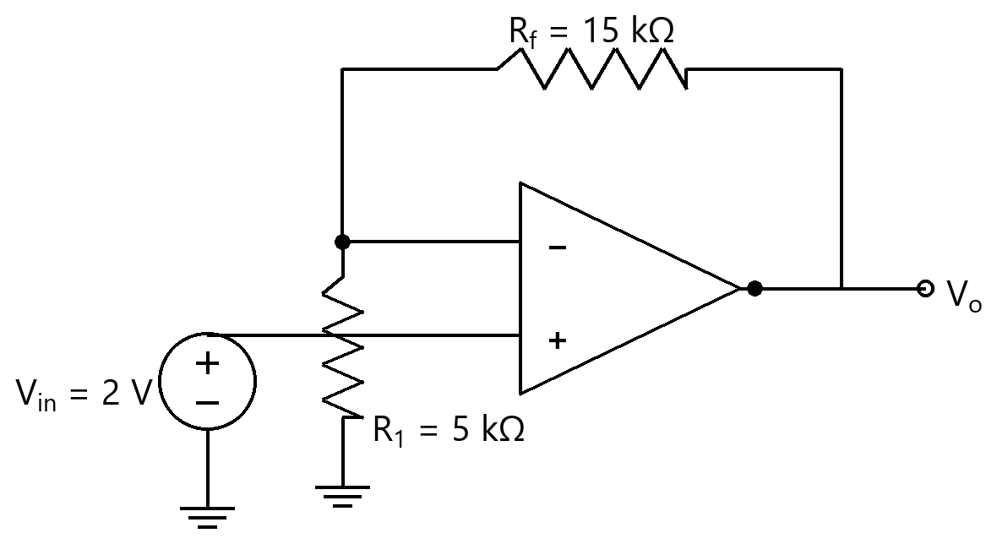
Option | -6.0 V  -6.0 V
Option | 8.0 V  8.0 V
Option | 6.0 V  6.0 V
Option | 2 V  2 V
Correct | 2
Explanation | 1. Core Concept & Formula  The non-inverting amplifier's closed-loop gain is 1 + $\scriptstyle R_f$/$\scriptstyle R_1$ (in phase with the input).  $\scriptstyle V_o = (1 + R_f/R_1)\cdot V_{in}$  2. Calculation Steps  $\scriptstyle V_o = (1 + 15/5)×2 = 8.0 V$  Final Answer: 8.0 V
Subject | Analog Electronics
Topic | OP-AMP and its Applications (Op-amp)
Correct Marks | 3
Incorrect Marks | 1
Hint | -
Video Solution | -
PYQ
OTS ID | AJEEEANE6120528

Question | 529
Type | MCQ
Body | For the ideal non-inverting op-amp amplifier shown, $\scriptstyle R_1$ = 1 kΩ (to ground), $\scriptstyle R_f$ = 9 kΩ (feedback) and $\scriptstyle V_{in}$ = 1 V at the (+) input. The output voltage $\scriptstyle V_o$ is:  दिखाए गए आदर्श अव्युत्क्रमी (non-inverting) op-amp प्रवर्धक के लिए, $\scriptstyle R_1$ = 1 kΩ (भू-संपर्क तक), $\scriptstyle R_f$ = 9 kΩ (पुनर्भरण) तथा (+) निवेश पर $\scriptstyle V_{in}$ = 1 V। निर्गत वोल्टता $\scriptstyle V_o$ है:  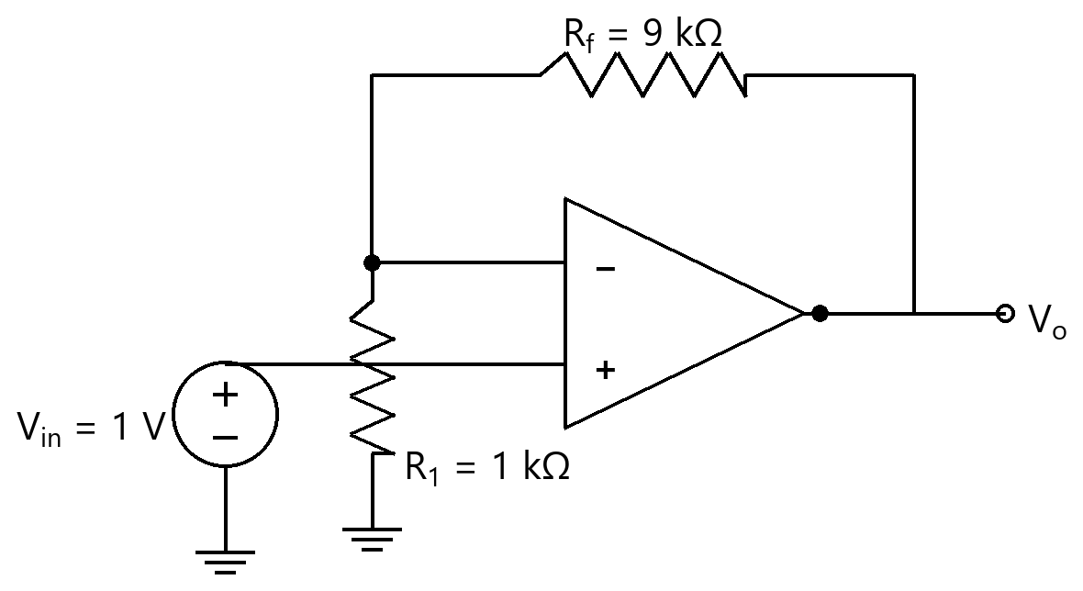
Option | -9.0 V  -9.0 V
Option | 9.0 V  9.0 V
Option | 10.0 V  10.0 V
Option | 1 V  1 V
Correct | 3
Explanation | 1. Core Concept & Formula  The non-inverting amplifier's closed-loop gain is 1 + $\scriptstyle R_f$/$\scriptstyle R_1$ (in phase with the input).  $\scriptstyle V_o = (1 + R_f/R_1)\cdot V_{in}$  2. Calculation Steps  $\scriptstyle V_o = (1 + 9/1)×1 = 10.0 V$  Final Answer: 10.0 V
Subject | Analog Electronics
Topic | OP-AMP and its Applications (Op-amp)
Correct Marks | 3
Incorrect Marks | 1
Hint | -
Video Solution | -
PYQ
OTS ID | AJEEEANE6120529

Question | 530
Type | MCQ
Body | For the ideal non-inverting op-amp amplifier shown, $\scriptstyle R_1$ = 10 kΩ (to ground), $\scriptstyle R_f$ = 40 kΩ (feedback) and $\scriptstyle V_{in}$ = 0.8 V at the (+) input. The output voltage $\scriptstyle V_o$ is:  दिखाए गए आदर्श अव्युत्क्रमी (non-inverting) op-amp प्रवर्धक के लिए, $\scriptstyle R_1$ = 10 kΩ (भू-संपर्क तक), $\scriptstyle R_f$ = 40 kΩ (पुनर्भरण) तथा (+) निवेश पर $\scriptstyle V_{in}$ = 0.8 V। निर्गत वोल्टता $\scriptstyle V_o$ है:  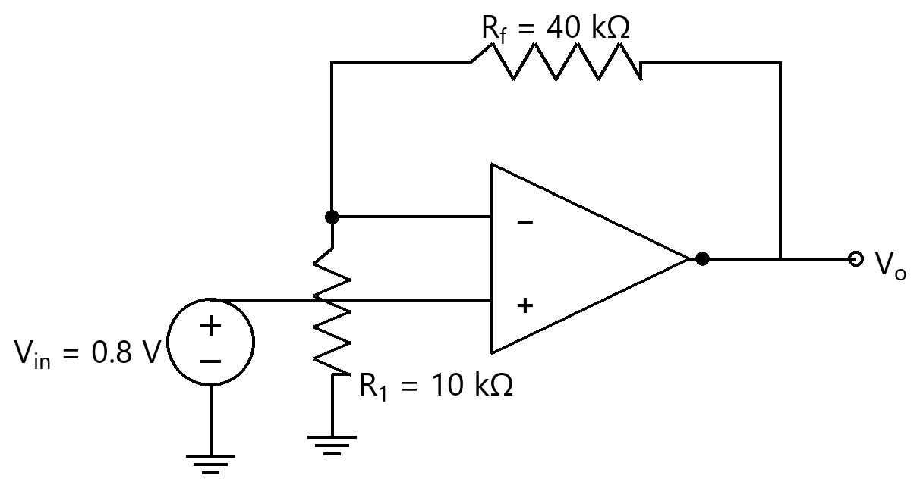
Option | -3.2 V  -3.2 V
Option | 3.2 V  3.2 V
Option | 0.8 V  0.8 V
Option | 4.0 V  4.0 V
Correct | 4
Explanation | 1. Core Concept & Formula  The non-inverting amplifier's closed-loop gain is 1 + $\scriptstyle R_f$/$\scriptstyle R_1$ (in phase with the input).  $\scriptstyle V_o = (1 + R_f/R_1)\cdot V_{in}$  2. Calculation Steps  $\scriptstyle V_o = (1 + 40/10)×0.8 = 4.0 V$  Final Answer: 4.0 V
Subject | Analog Electronics
Topic | OP-AMP and its Applications (Op-amp)
Correct Marks | 3
Incorrect Marks | 1
Hint | -
Video Solution | -
PYQ
OTS ID | AJEEEANE6120530

